2016 Mathematics Standards of Learning

Algebra Readiness Formative Assessment

# 6.13

1. Using the given key and equation mat, represent and solve the following linear equation algebraically. Then, confirm your solution.



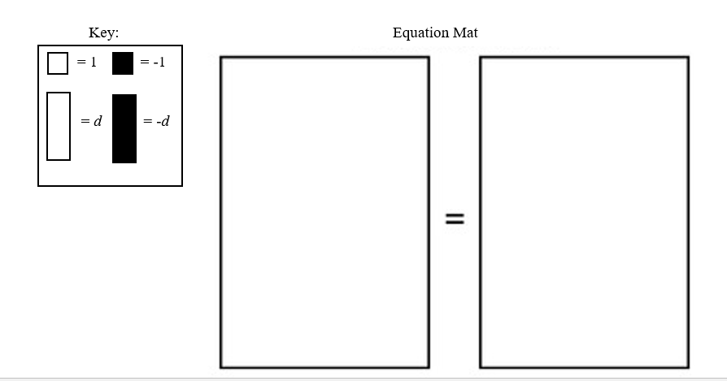

1. Explain how to solve the algebraic equation and justify your answer.



1. Select the two methods that can be used to solve the algebraic equation.

<math xmlns="http://www.w3.org/1998/Math/MathML"><mo>-</mo><mn>2</mn><mi>x</mi><mo>&#xA0;</mo><mo>=</mo><mo>&#xA0;</mo><mn>12</mn></math>

* Add -2 to each side.
* Multiply each side by -2
* Divide each side by -2.
* Add  to each side.
* Multiply each side by 
* Divide each side by 

1. Represent and solve the following situation as an algebraic equation.

Richmond City Schools provides 3 buses for a school field trip. If 72 students are going on the school field trip, how many students will be on each bus? Assume the students (*s*) are equally divided on each bus.

Algebraic Equation: ________________________________

There will be _____students on each bus.

1. In the following expression, drag and drop the correct algebraic name:

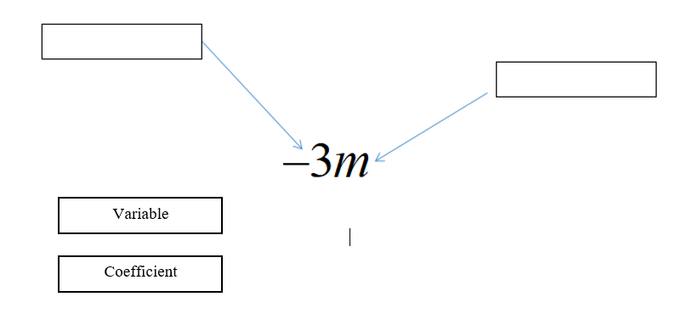

1. Identify three verbal statements that represent the expression below.



* The product of four and a number decreased by 16
* The quotient of four and a number minus 16
* Four times a number less than 16
* Sixteen less than four times a number
* The difference between four times a number and 16
* Four more than a number decreased by 16

1. How many terms are in the following expression?



1. Which method can be used to solve the algebraic equation below?



1. Subtract 6 from both sides of the equation
2. Add 6 to both sides of the equation
3. Subtract 13 from both sides of the equation
4. Add 13 to both sides of the equation
5. How would you solve the equation below?



1. Multiply both sides of the equation by 
2. Multiply both sides of the equation by 3
3. Divide both sides of the equation by 3
4. Divide both sides of the equation by -6
5. Which solution will make the linear equation statement true?

13.75 = -2.5*z*

1. *z* = 5.5
2. *z* = -16.25
3. *z* = 16.25
4. *z* = - 5.5

Virginia Department of Education 2018