2016 Mathematics Standards of Learning
Algebra Readiness Formative Assessment

6.12d

- Create a situation that represents a proportional relationship. Create a table of values and a graph to represent this relationship.

- Suzanne is selling 4 boxes of cookies for $10. A proportional relationship exists between the number of boxes of cookies, x, and the total cost, y. Create a graph with at least 4 points that represents the same proportional relationship.

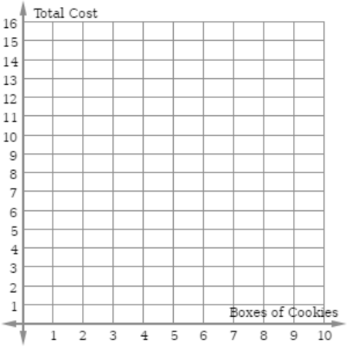

- The table represents the relationship between the dollars earned selling T-shirts for each day that Alejandro worked.
Shirts Sold | Dollars Earned
6 | 75
9 | 112.50
11 | 137.50

Determine and describe the unit rate for the price that he used for the cost of each shirt.

On the coordinate graph, plot points that would represent the relationship between the dollars earned and the sale of 1, 2, and 3 shirts.

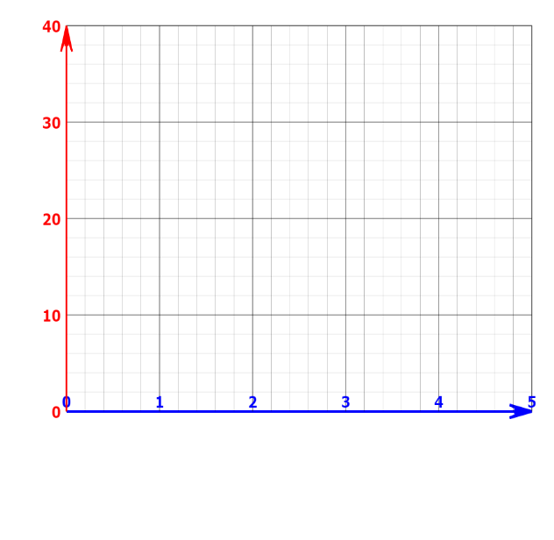

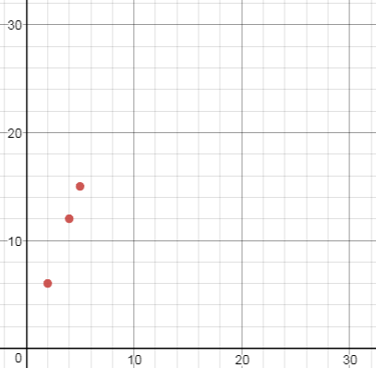
- The graph below shows the relationship between the number of movies rented to the total cost.

Cost

Number of Movies Rented

Which table below represents the same proportional relationship?
- B.
Movies Rented | Cost
1 | 3
3 | 5
6 | 8
Movies Rented | Cost
1 | 3
10 | 13
12 | 24

C. D.
Movies Rented | Cost
7 | 21
10 | 30
13 | 39
Movies Rented | Cost
7 | 10
3 | 6
6 | 9
C

Virginia Department of Education 2018

