2016 Mathematics Standards of Learning
Algebra Readiness Formative Assessment

6.12c

- Given:
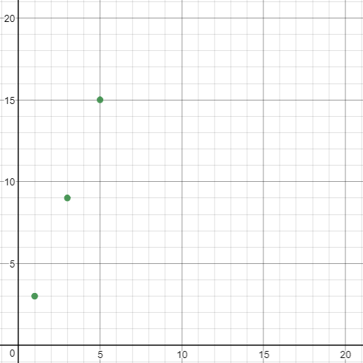
Determine whether a proportional relationship exists, and explain why.

- Given:
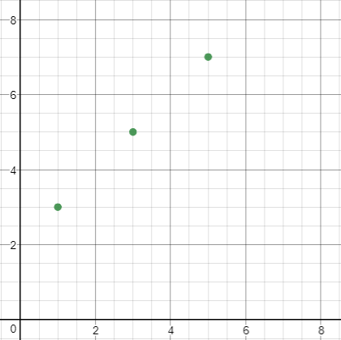
Determine whether a proportional relationship exists, and explain why.

- Sarah is shopping for school supplies and sees signs that have the following descriptions:
  - Erasers 2 for $1 or 10 for $4
  - Pencils $0.25 each
Does the number of erasers purchased and the cost of the erasers represent a proportional relationship? Explain why or why not.
Does the number of pencils purchased and the cost of the pencils represent a proportional relationship? Explain why or why not.
- Jose is mixing paint for an art project. He uses cup of yellow paint for every cup of blue paint. Does Jose’s paint mix represent a proportional relationship? Explain.

- Which set of ordered pairs represents a proportional relationship?

  - (3,15), (5,17), (9,21)
  - (3,15), (5,25), (9,45)
  - (3,15), (5,23), (9,39)
  - (3,15), (5,27), (9,51)

- Which table represents a proportional relationship?

x | y
1 | 5
2 | 6
3 | 7

x | y
1 | 3
2 | 6
3 | 9

x | y
0 | 3
3 | 6
6 | 9

x | y
0 | 5
3 | 7
6 | 9

Virginia Department of Education 2018

