2016 Mathematics Standards of Learning
Algebra Readiness Formative Assessment

5.19c

- Matthew scored two times as many points as Justin. Write an expression to represent the number of points Matthew scored. Explain the meaning of the variable.

- For each verbal expression, write an algebraic expression.
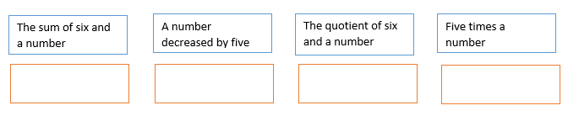

- Choose the algebraic expression that represents the verbal phrase,
“the difference of five and a number”
  - 5(x)
  - 5 + x
  - 5 - x
  - $\frac{5}{x}$

- Choose the algebraic expression that best represents the verbal phrase,
“Twenty more than a number, c

  - 20
  - 20(c)
  - c + 20
  - 20 – c

- Choose the algebraic expression that best represents the verbal phrase.
“the quotient of a number and ten”

  - $\frac{10}{x}$

  - 10 + x

  - $\frac{x}{10}$

  - 10 - x

Virginia Department of Education 2018

