2016 Mathematics Standards of Learning

Algebra Readiness Formative Assessment

# 1A.7f

1. Which table of values best represents the following verbal description: a number, *y,* is equal to nine less than the square of a number, *x.*

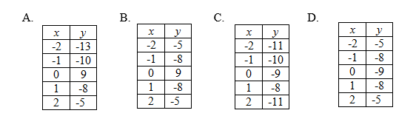

1. Which graph best represents the following verbal description: four increased by the quotient of a number, *x*, and 3 is equal to a number, *y.*

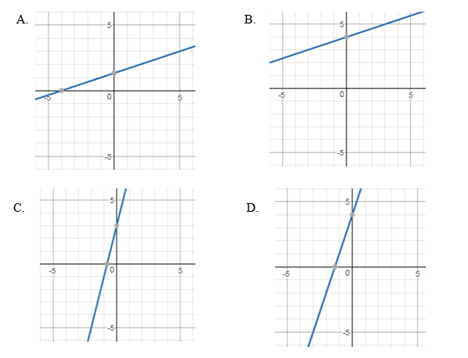

1. Which graph best represents the following table of values:

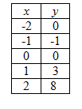

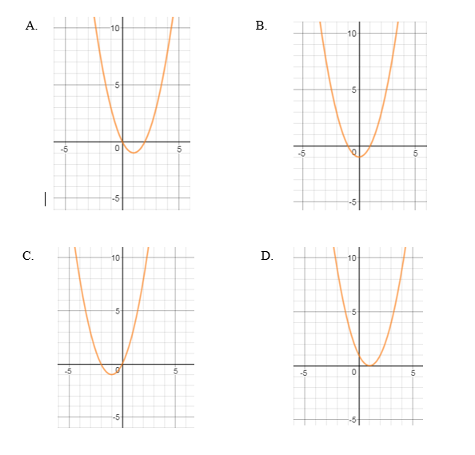

1. Which table of values best represents the following linear equation, ?

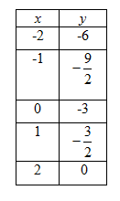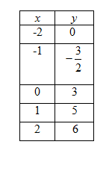

1. B.

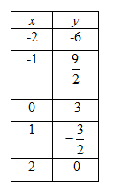

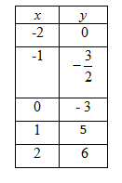 C. D.

Virginia Department of Education 2018