2016 Mathematics Standards of Learning

Algebra Readiness Formative Assessment

# 1A.7cd

1. Determine the zero(s) of the function graphed below and explain why they are the zeros for the function.

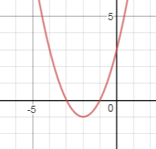

Zeros: __________________________

Explanation: _________________________________________________________________

________________________________________________________________________

1. Determine the zero(s) of the function graphed below.

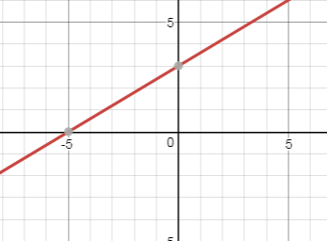

Zero(s): _______________________________________

Zeros can also be referred to as __________________________________________.

1. What are the zero(s) of the function?

zero(s):_______________________

1. What are the zero(s) of the function?

zero(s):_________________________

1. From the graph below, determine the x-intercepts, y-intercepts, zeros, possible factors for the function, and possible polynomial function.

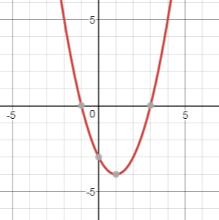

x-intercepts:_________________________

y-intercepts:_________________________

zero(s):_____________________________

factors of the polynomial:_____________________________

polynomial function written in factored form: f(x)=____________________________

1. From the graph below, determine the x-intercepts, y-intercepts, zeros, possible factors for the function, and possible polynomial function.

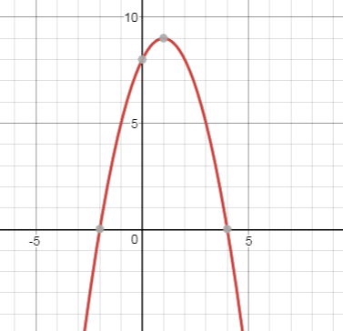

x-intercepts:_________________________

y-intercepts:_________________________

zero(s):_____________________________

factors of the polynomial:_____________________________

polynomial function written in factored form: f(x)=_____________________________

Virginia Department of Education 2018