2016 Mathematics Standards of Learning

Algebra Readiness Formative Assessment

1A.7abe

1. Create an example of a relation that also represents a function. Write this relation as a set of ordered pairs, a mapping, and as an *x,*y table of values. Use a minimum of 3 points.

Answer:

1. If, what is?
2. Which ordered pair(s) satisfy the function.

(-8, -1)

(1, 3)

(0, -5)

(-1, -8)

(-5, -15)

(3, 1)

(-2, -11)

(-2, -1)

1. If, what is?
2. 
3. 3
4. 7
5. -27
6. What is the range of the graph?

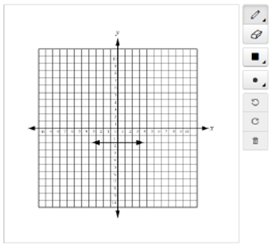

1. 
2. 
3. 
4. 
5. The function below contains ordered pairs of the form (*x, y*).



What is the domain of the function?

1. 
2. 
3. 
4. 
5. If and, what is the value of x?
6. 
7. 
8. 
9. 
10. Which of these ordered pairs could not lie on the graph of a function?
11. (-1, 0); (-1,-1)
12. (-1, 0); (1, -1)
13. (-1, 1); (1, 0)
14. (0, -1); (1, 1)
15. What is the domain and range for the line segment graphed below?

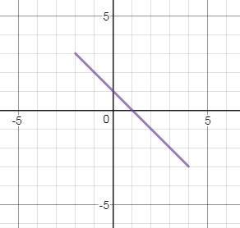

1. D = ; R = 
2. D = ; R = 
3. D = ; R = 
4. D = ; R = 

Virginia Department of Education 2018