2016 Mathematics Standards of Learning

Algebra Readiness Formative Assessment

# 1A.6c

1. Graph the line  and describe the transformation when compared to the line as shown.

graph of a line


1. Avery is coordinating a car wash to raise money for travel expenses for her soccer team’s upcoming tournament. She spent $10 in supplies and will charge $6 per car washed. Graph the linear equation represented by this situation.

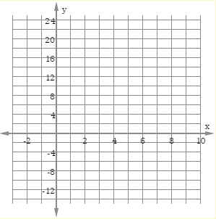

1. Graph the equation 

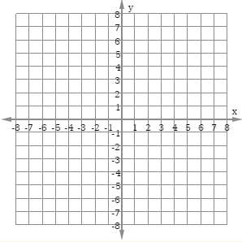

1. Which of the following equations represents the linear function graphed below?

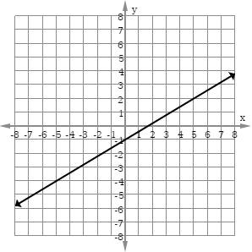

* 1. 
  2. 
  3. 
  4. 

1. Which graph represents the equation ?
   1. B.

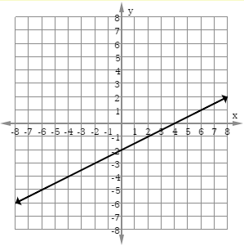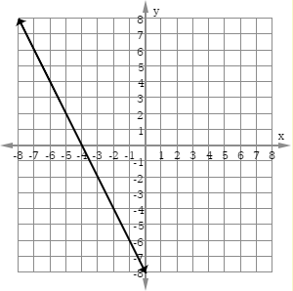

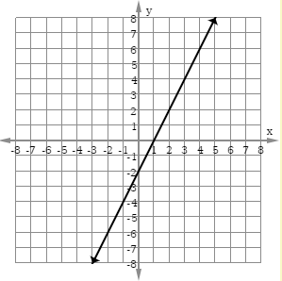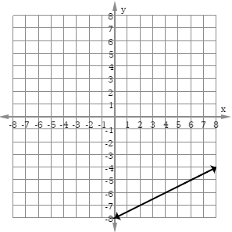C. D.

Virginia Department of Education 2018