2016 Mathematics Standards of Learning

Algebra Readiness Formative Assessment

# 1A.6b

1. Write an equation for the line that passes through (1, -9) and (1, 12).
2. Write an equation for the line graphed below in slope-intercept, standard and point-slope forms.

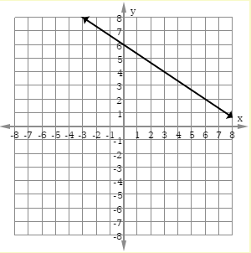

1. Select the two equations that represent lines perpendicular to the line graphed below.

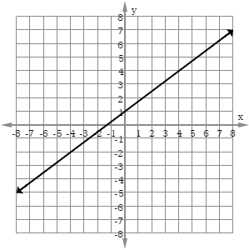

* 
* 
* 
* 
* 
* 

1. Which is the equation of a horizontal line?
   1. 
   2. 
   3. 
   4. 
2. Which equation represents a line with a slope of -1 that passes through (8,5)?
   1. 
   2. 
   3. 
   4. 
3. Which is an equation of a line that has a *y*-intercept of 7 and is parallel to the graph of ?
   1. 
   2. 
   3. 
   4. 

Virginia Department of Education 2018