2016 Mathematics Standards of Learning

Algebra Readiness Formative Assessment

1A.5bd

1. Graph the solution for the following linear inequality.



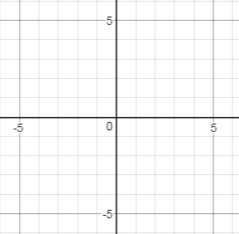

1. Graph the solution for the following linear inequality.





1. Graph the solution to the following system of two linear inequalities.







1. Graph the solution to the following system of two linear inequalities.







1. Select the ordered pairs that are solutions for the system of linear inequalities graphed below.

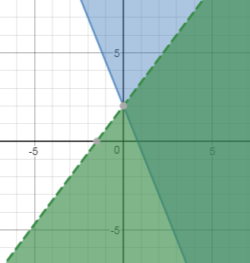

| (5,0) | (0,2) | (0,0) |
| --- | --- | --- |
| (5,5) | (0, -2) | (2,0) |

Virginia Department of Education 2018