2016 Mathematics Standards of Learning

Algebra Readiness Formative Assessment

1A.5ac

1. What is the solution to 
2. 
3. 
4. 
5. 
6. **Solve** and **graph** the solutions to the inequality, 

Solution:__________________________

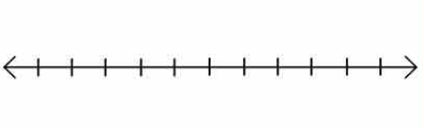

1. Last year, Girl Scout troop #342 sold *b* boxes of cookies. This year, the troop needs to meet a goal of selling at least 420 boxes of cookies. In order to meet that goal, they must sell at least three times the number of boxes of cookies sold last year plus 90. What was the minimum number of boxes of cookies the Girl Scout troop #342 sold last year?

Answer: ____________________________________

1. Brendon wants to travel to Australia over spring break. His mom said she will double the amount he is able to save during the school year to help him pay for the $1,850 plane ticket. Brendon currently has $560 in his savings account. Which inequality best represents the least amount of money he will need to contribute to cover the cost of the plane ticket?
2. 
3. 
4. 
5. 
6. Select the graph that represents the solution to the system of inequalities.



1. 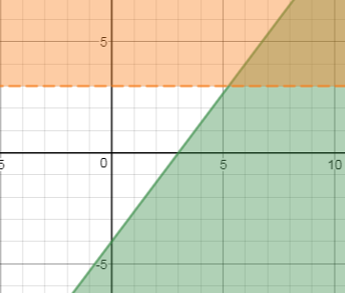 B.

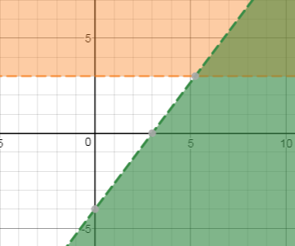

C. D.

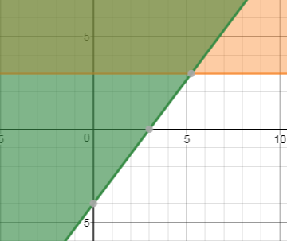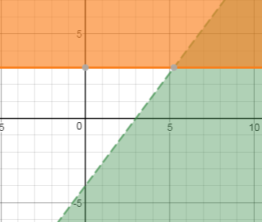

1. Select the graph that represents the solution to the system of inequalities



A. B.

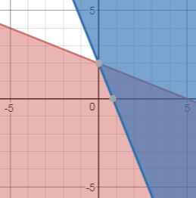 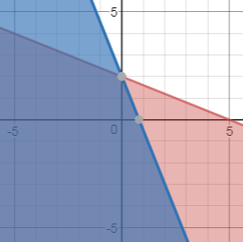

C. D.

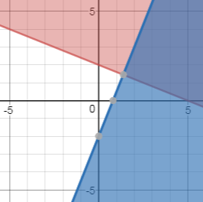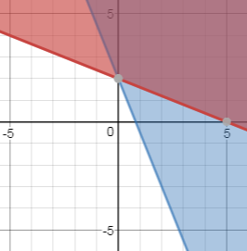

1. Provide the inequality statements that would produce the graph of the system of linear inequalities below.

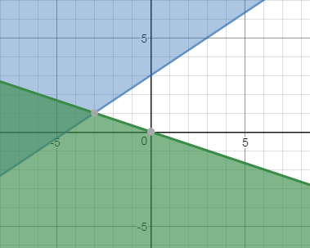

System of Linear Inequalities:

Virginia Department of Education 2018