2016 Mathematics Standards of Learning

Algebra Readiness Formative Assessment

# 1A.4de

1. 

If the first equation in this system of linear equations is solved for *y* correctly, then its equivalent equation is. Solve the system of equations using the substitution method. Show your work.

1. 

The system of linear equations above can be solved by elimination. In order to eliminate the *x* in the system of equations, what operation should be performed on the second equation?

Answer:__________________________________________________________________

1. Use the graph below to determine the solution the system of linear equations.

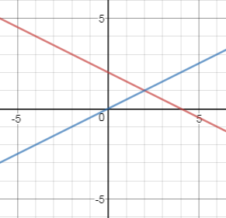

Solution: _______________

1. 

Solve the system using any method.

Solution: ______________________________

1. 

The system of linear equations above has –

1. no solution
2. one solution
3. only two solutions
4. infinite solutions
5. If the parallel lines graphed below represent a linear system of equations, what can be said about the system of equations?

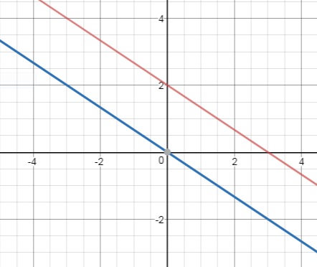

1. There is no solution.
2. There is only one solution.
3. There are only two solutions.
4. There are infinite solutions.
5. Tana has $5.50 in dimes and quarters. She has 8 more quarters than dimes. Represent this situation with a system of linear equations. Solve the system.

| System of linear equations | Solution |
| --- | --- |

1. A local community sold 125 concert tickets recently. The dollar amount collected wa $835. Adult tickets, *A* sold for $8 each and children tickets, *C* sold for $5 each. Write a system of linear equations that models this situation.
2. Farmer John has goats and chickens on his farm. The total number of 4 legged goats and 2 legged chickens is 18. His son, Joseph counted 56 animal legs on the farm. Represent this situation with a system of linear equations and find the number of goats (*G*) and chickens (*C*) on the farm.

| System of linear equations | Solution |
| --- | --- |

Virginia Department of Education 2018