8M.3ab

1. falls between which two consecutive numbers? Select two answers

from the choices below.

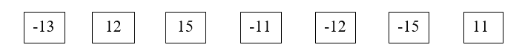

2.  falls between which two sets of consecutive numbers?

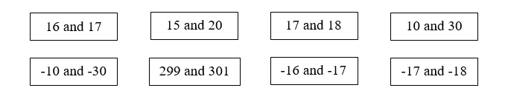

3. The square root of 170 falls between which two consecutive whole numbers?

_____ and _____

4. Which of these best represents? A number between –

1. 4 and 5
2. 5 and 6
3. 6 and 7
4. 8 and 9

5. Between which two consecutive numbers does  lie?

1. -4 and -5
2. -5 and -6
3. -6 and -7
4. -7 and -8

6. What are the positive and negative square roots of 121? Select two answers from the choices below.

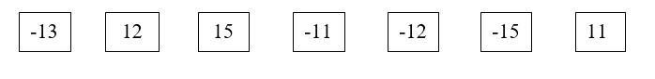

7. What is ?