2016 Mathematics Standards of Learning

Algebra Readiness Formative Assessment

8.2

1. Write the following labels in the appropriate box to best represent the subsets of the real number system.

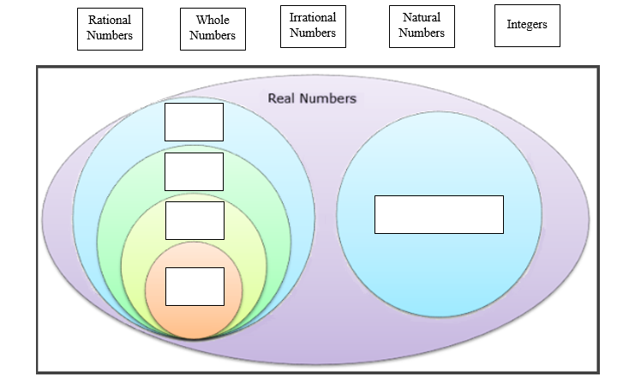

1. Fill in the blanks to make a true statement about  (choose from the choices below)

This is a(n) since it can be

expressed as .

repeating decimal

irrational number

rational number

terminating decimal

1. Sort the following list of numbers into rational and irrational numbers.

  0 4.285…  **  **

| Rational Numbers | Irrational Numbers |
| --- | --- |
|  |  |
|  |  |
|  |  |
|  |  |

1. Write the letter of each definition next to the corresponding subgroup of the real number system.

____Natural Numbers A. the set of whole numbers and their opposites 

____Whole Numbers B. the set of counting numbers and zero 

____Integers C. the set of all nonrepeating, nonterminating decimals 

____Rational Numbers D. the set of counting numbers 

____Irrational Numbers E. the set of all numbers that can be expressed as fraction in form

, where  and  are integers and  does not equal zero



1. Identify which statement is false.

The product of two rational numbers is rational.
The sum of a rational number and irrational number is irrational.
The sum of a rational number and an irrational number is rational.
The product of a nonzero rational number and an irrational number is irrational.

1. Which Venn diagram best represents the following sets of numbers?

, , , 

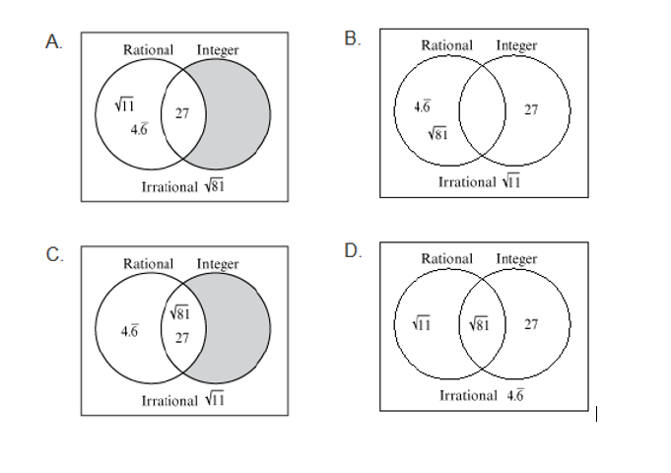

1. Which of the following can be defined as an integer, but not a whole number?
2.  B.  C.  D. 
3. The number 3.7 is best described as –
4. a rational number
5. an integer
6. a whole number
7. an irrational number
8. Which is a true statement concerning the rational number ?
9. This number can be expressed in the form , where  and  are integers and .
10. This number cannot be expressed in the form , where  and  are integers and .
11. This number can be expressed in the form , where  and  are integers and .
12. This number cannot be expressed in the form , where  and  are integers and .
13. Which of these is a rational number?
14. 
15. 0.414114…
16. 
17. 

Virginia Department of Education 2018