2016 Mathematics Standards of Learning

Algebra Readiness Formative Assessment

8.1

1. Put the following numbers in ascending order.

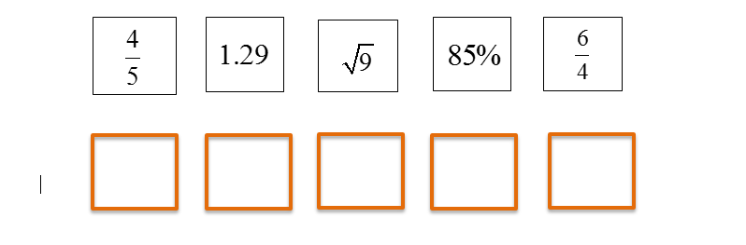

1. Put the following numbers in descending order.

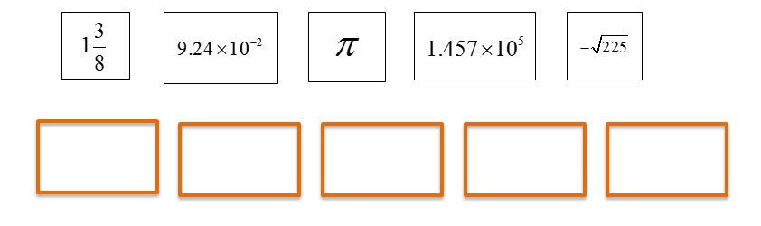

1. Place the following numbers on the number line.



-9.2587…



7.99524…



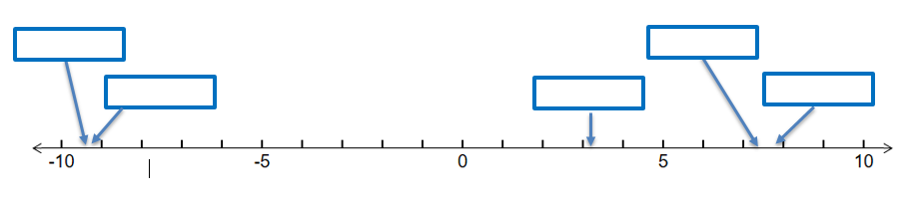

1. Which set of numbers are listed in descending order?
2. 
3. 
4. 
5. 
6. Which number line correctly represents the irrational numbers listed below?

    









Virginia Department of Education 2018