2016 Mathematics Standards of Learning

Algebra Readiness Formative Assessment

7.1e

1. Represent and on the number line below.

From -10 to 10

1. What is the absolute value of zero? ____

Why? __________________________________________________________________ ________________________________________________________________________

1. Identify each true statement.

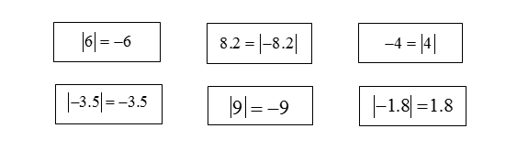

1. Evaluate the expression  and write your answer in the space provided. ______
2. Two cars are parked on the number line below. The front of the blue car is parked at point -15 and the front of the red car is parked at point 25. At which point on the number line below should the front of the red car drive to in order to have the same absolute value as the blue car?

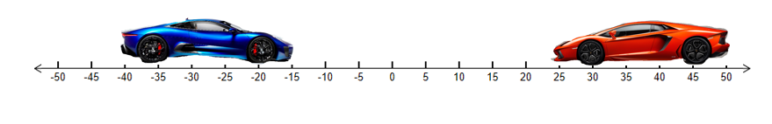

The red car must drive to point _______.

1. Absolute value is –
2. the distance from the number and zero on a number line.
3. represented with the symbols .
4. always positive.
5. all of the above.
6. Which point on the number lines below represents the greatest absolute value?

Choice A shows 9
Choice B shows -17
Choice C shows 5
Choice D shows -15

8. Draw two points on the number line below that represent the absolute value of nine.

From -10 to 10

9. The absolute value of -23 is –

A. -23, because the absolute value of a number is that number

B. 23, because the absolute value of a number is the number’s distance from zero

C. 23, because absolute value is the opposite of a given number

D. 0, because the absolute value of a number is the sum of that number and its opposite

Virginia Department of Education 2018