2016 Mathematics Standards of Learning

Algebra Readiness Formative Assessment

7.1d

1. Identify the two perfect squares listed below.

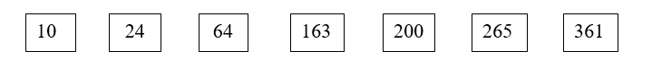

1. Use your knowledge of perfect squares and square roots to complete the table below.

| Square Root | Perfect Square |
| --- | --- |
|  | 4 |
| 3 |  |
|  | 16 |
|  | 121 |
| 15 |  |
|  | 400 |

1. Which of the following pictures does *not* represent a perfect square?

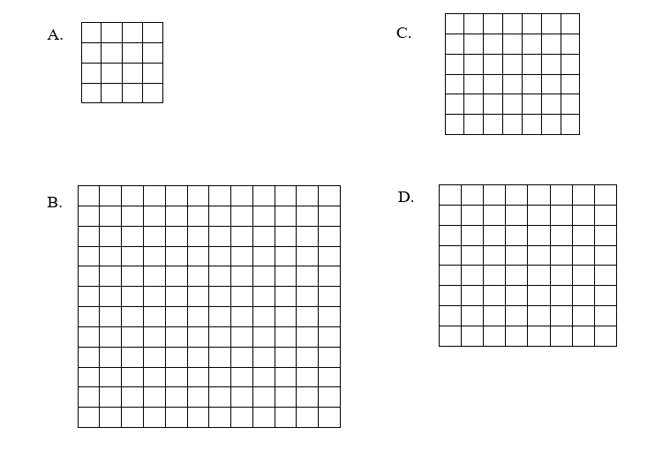

1. Which of the following represents?
2. 13
3. 14
4. 15
5. 16
6. What is?
7. 3
8. 6
9. 18
10. 81

6. Which of the following has a square root of 16?

A. 4

B. 32

C. 186

D. 256

Virginia Department of Education 2018