2016 Mathematics Standards of Learning

Algebra Readiness Formative Assessment

7.1c

1. Put the following numbers in ascending order.

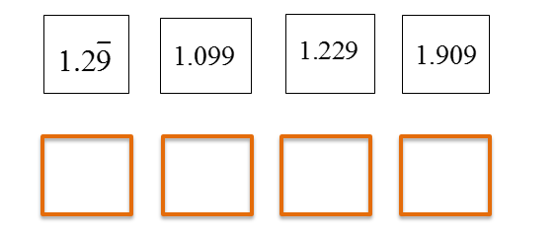

1. Put the following numbers in order from greatest to least.

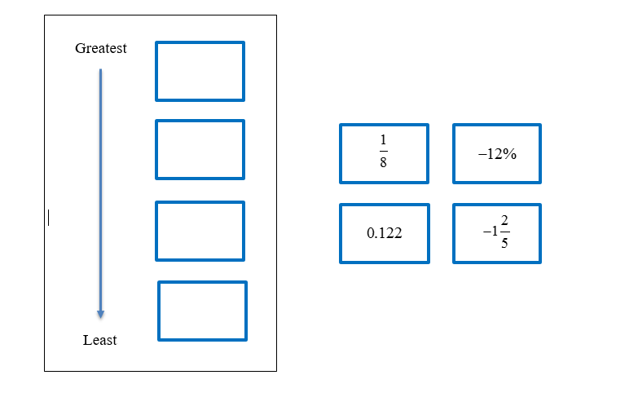

1. Circle all of the numbers that make the inequality statement true.



    

    

1. Which set of numbers is listed in descending order?
2. 
3. 
4. 
5. 
6. Which list of numbers is written in ascending order?
7. 
8. 
9. 
10. 

Virginia Department of Education 2018