2016 Mathematics Standards of Learning

Algebra Readiness Formative Assessment

7.1b

1. Put the following numbers in order from least to greatest.

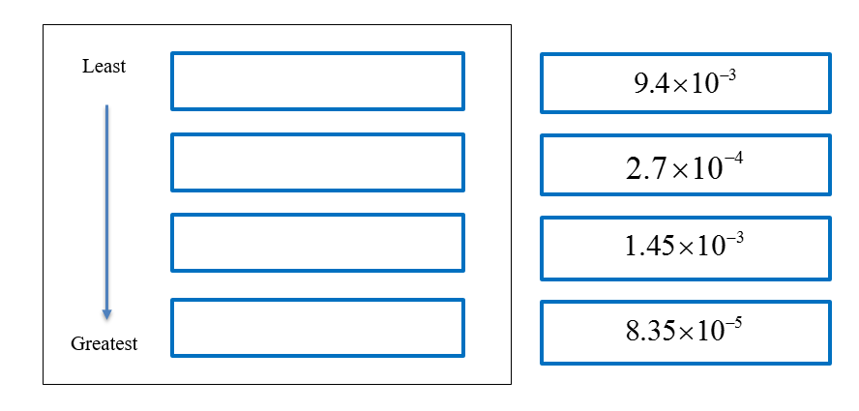

1. Write 31 million, 4 hundred and fifty-two thousand in standard form. Then, convert the number into scientific notation.

Standard Form Scientific Notation

1. Circle all of the numbers that make the inequality statement true.



   

   

1. What is 0.00000283 written in scientific notation?
2. 
3. 
4. 
5. 
6. Which list of numbers is written in descending order?
7. 
8. 
9. 
10. 

Virginia Department of Education 2018