2016 Mathematics Standards of Learning

Algebra Readiness Formative Assessment

6.4

1. Use your knowledge of perfect squares to complete the table below.

| Square Root | 1 | 3 |  | 11 |  | 20 |
| --- | --- | --- | --- | --- | --- | --- |
| Perfect Square | 1 | 9 | 49 |  | 196 |  |

1. Identify all of the answer choices that are equivalent to.

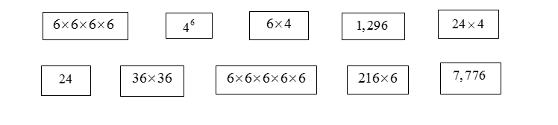

1. What is the value of?



A. 1,000

B. 100,000

C. 1,000,000

D. 10,000,000

4. Which best describes the numbers in the pattern below?

100, 121, 144, 169, …

A. square roots

B. perfect squares

C. scientific notation

D. exponential notation

5. Max placed the numeral 10,000 in the place value chart.

| Ten Thousands | Thousands | Hundreds | Tens | Ones |
| --- | --- | --- | --- | --- |
| 1 | 0 | 0 | 0 | 0 |

What is 10,000 written in powers of 10?

A. 

B. 

C. 

D. 

6. Based on the pattern show below, what is the value of?



A. 20

B. 68

C. 256

D. 1,024

7. A pattern of increasing perfect squares is shown.

9, 16, 25, 36, 49, 64, …

What number comes next in this pattern?

A. 100

B. 81

C. 79

D. 65

8. How should be written in a place value chart?

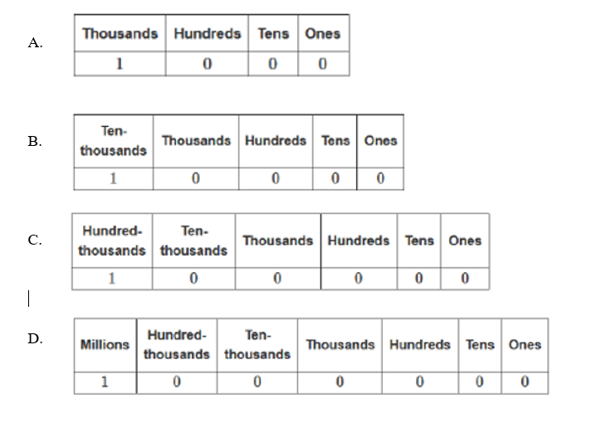

Virginia Department of Education 2018