2016 Mathematics Standards of Learning

Algebra Readiness Formative Assessment

6.3c

1. Represent  and on the number line below.

From -10 to 10.

2. What is the absolute value of zero? ____

Why? __________________________________________________________________ ________________________________________________________________________

3. Identify the two true statements below.

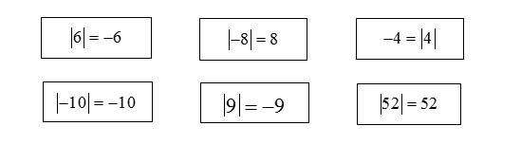

4. Bunny A and Bunny B are hopping on the number line below. What point should

Bunny B hop to in order to have the same absolute value as Bunny A?

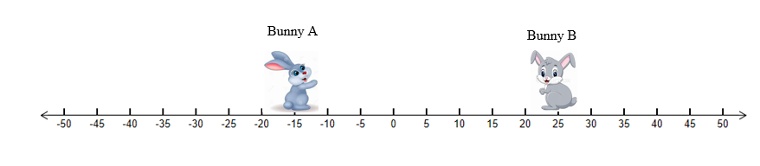

Bunny B should hop to point _______.

5. Absolute value is –

1. the distance from zero.
2. shown with the symbols .
3. never a negative value
4. all of the above.

6. Which point on the number lines below represents the greatest absolute value?

Choice A is 4
Choice b is -10
Choice C is 5
Choice D is -1

Virginia Department of Education 2018