2016 Mathematics Standards of Learning

Algebra Readiness Formative Assessment

6.3b

1. Use the number line to put the following integers in ascending order.

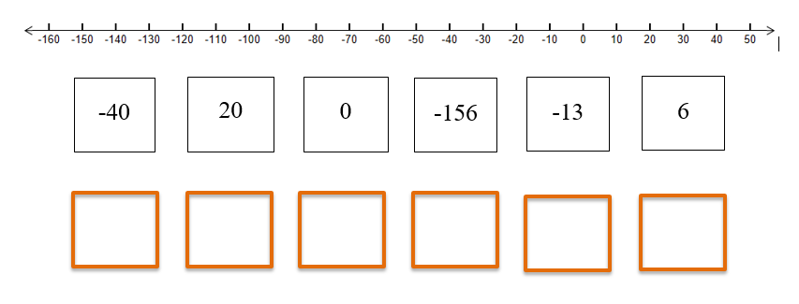

1. Circle all of the integers on the number line that satisfy the inequality below.



from -7 to 7

1. Identify all of the following statements that are true.

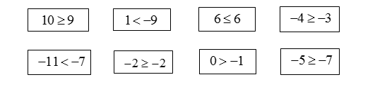

1. Which statement is true when comparing  and ?

A. , because lies to the right of  on the number line

B. , because lies to the right of  on the number line

C. , because lies to the left of  on the number line

D. , because lies to the left of  on the number line

5. Which set of integers is listed is descending order.

A. 

B. 

C. 

D. 

Virginia Department of Education 2018