2016 Mathematics Standards of Learning

Algebra Readiness Formative Assessment

6.3a

1. If you move the blue point ten units to the left, what number will it land on? _____

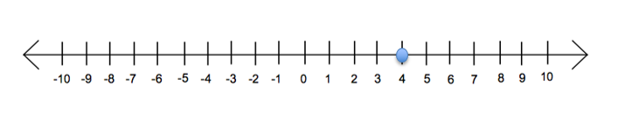

2. Use the key to answer the question below.

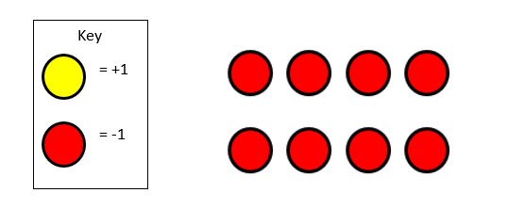

What integer is represented in the illustration above? _____

3. Illustrate where six degrees below zero is located on the thermometer below.

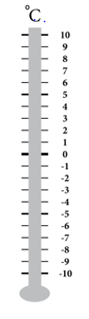

4. Shade all of the boxes that contain an integer.

|  |  |  |
| --- | --- | --- |
|  |  |  |
|  |  |  |

5. Identify each integer represented on the number line below.

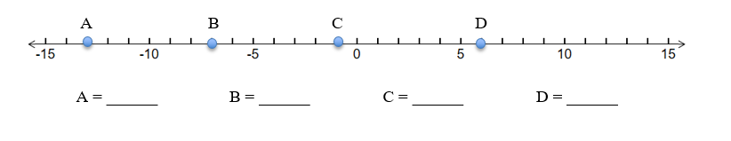

6. Write the integer represented by each situation below.

A loss of 5 yards on the football field _____

A withdrawal of sixty dollars from the ATM _____

A golfer ends up with a score 9 strokes over par _____

Water rises 35 feet above sea level _____

A mom loses 12 pounds after childbirth _____

A deposit of $100 at the bank _____

A temperature eleven degrees below zero _____

Virginia Department of Education 2018