2016 Mathematics Standards of Learning

Algebra Readiness Formative Assessment

6.2b

1. Circle the inequality symbol that makes each pair of pictorial representations true.

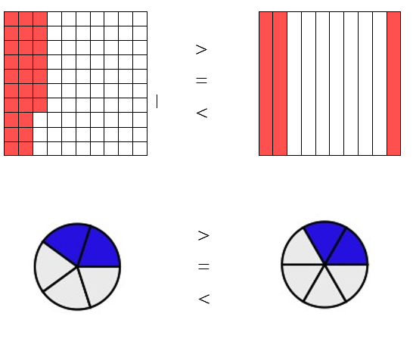

1. Put the following numbers in ascending order.

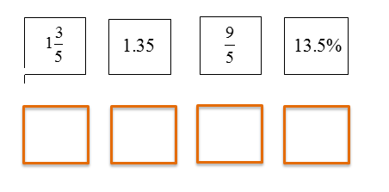

3. Put the following numbers in order from greatest to least.

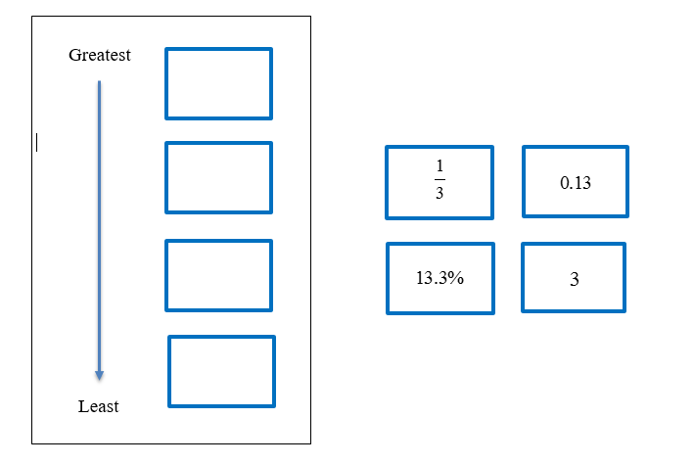

4. Circle two numbers that make the inequality statement true.



     

5. At soccer practice, Keith ran  of a mile, Jake ranof a mile, and Julian ran  of a mile.

Put these distances in descending order.

A. 

B. 

C. 

D. 

6. Which number goes in the blank space to make the inequality statement true?



A. 9

B. 10

C. 11

D. 12

7. The table shows changes in gasoline prices per gallon over one year.

| Gasoline Prices | |
| --- | --- |
| Month | Change in cost per gallon |
| January | 2.075 |
| April |  |
| August | 208.3% |
| December |  |

Which statement about these prices is true?

A. January > August

B. April > January

C. December < January

D. January < December

Virginia Department of Education 2018