2016 Mathematics Standards of Learning
Algebra Readiness Formative Assessment

5.3b
- Jamika is adding two even numbers. Using numbers, pictures, and words, explain if the sum of the two numbers will be even or odd.

- Latisha is trying to determine if the picture below represents and even or odd number. Using the picture explain to Latisha if the number is odd or even.

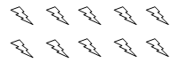
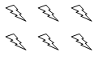

- Draw 7 triangles, then explain if the number 7 is even or odd.

- Ericka has an even number of pencils in her pencil case. Which number could not represent the number pencils Ericka has in her pencil case?

- 44 pencils
- 52 pencils
- 33 pencils
- 50 pencils

- Which best describes the set of numbers:
25, 47, 39, 61, 63, 87

- They are all even numbers
- They are all odd numbers
- Some are odd and some are even
- None are even or odd numbers
Virginia Department of Education 2018

