2016 Mathematics Standards of Learning
Algebra Readiness Formative Assessment

5.2a
- Using the grid, model $\frac{3}{20}$ , then write the decimal that is equivalent.

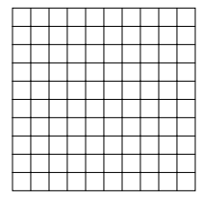

- Match each fraction to its equivalent decimal form.

$$\frac{7}{8}$$
$$\frac{2}{5}$$
$$\frac{8}{25}$$

$$0. 875$$

0.32
0.40

- Sarah ate $\frac{3}{8}$ of a pie. Which decimal represents the amount of pie that is left?

- 0.375
- 0.625
- 0.325
- 0.675

- Which fraction is not equivalent to the decimal 3.3$\overline{3}$ ?

- $3 \frac{2}{6}$

- $3 \frac{4}{12}$

- $3 \frac{6}{9}$

- $3 \frac{5}{15}$

- Richmond received 0.4 inches of rain on Monday. Which of the following shows how much rain fell in Richmond?

- $\frac{4}{100} inches$

- $\frac{4}{5} inches$

- $\frac{1}{4} inches$

- $\frac{2}{5} inches$
Virginia Department of Education 2018

