AR Remediation Plan – Data Representation and Interpretation

Scatterplots

STRAND: Probability and Statistics

STRAND CONCEPT: Data Representation and Interpretation

SOL 8.13a; 8.13b

Remediation Plan Summary
Students will create scatterplots to analyze relationships in data.

Common Misconceptions
Students will confuse the x and y axis. They are not sure which one to use to graph the data. Students have a difficult time creating a consistent scale.

Materials
- Comparing Data in a Graph verses a Table
- Graph paper,
- measuring tape,
- recording sheet,
- graphing calculator (optional)
- Additional ideas for determining positive, negative or no relationships

Introductory Activity
Project the “Comparing Data in a Graph verses a Table”. Ask the students if they can see a trend in the graph? Can you see a trend in the data table? Is the data easier to read in the graph or the table? How do graphs help you understand data? Have a discussion with the students about the purpose of a scatterplot. How we use them and how they assist people in analyzing trends.

Plan for Instruction
- Pose the question: Do you think there is a relationship between a person’s arm span and a person’s height?
- Each group should use a measuring tape to measure the height and arm span of each person in the group. Choose a unit either inches or centimeters to make sure everyone uses the same unit. To measure arm span, lift both arms to shoulder height and measure from fingertip to fingertip across the back.
- Record the value of each person’s measurements in the chart on the worksheet.
- Collect the data. Fill in the recording sheet.
- Graph the data on a coordinate plane. Label the horizontal axis “Height” and the vertical axis “Arm Span”.
- Draw a trend line. What kind of relationship does the trend line show? (As an extension, a graphing calculator could be used to determine the line of best fit for the data.)

Pulling It All Together (Reflection)
See additional ideas for determining positive, negative or no correlations ideas to have additional lessons.

Note: The following pages are intended for classroom use for students as a visual aid to learning.

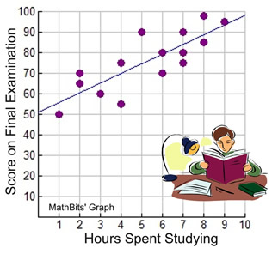
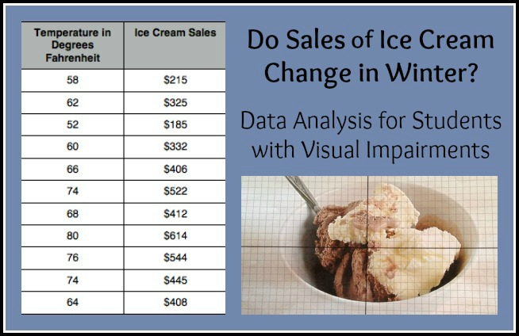
Comparing Data in a Graph verses a Table

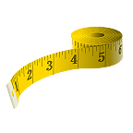
RECORDING SHEET

NAME | HEIGHT | ARM SPAN

Additional Ideas for Determining Positive, Negative, or No Relationship

- height and shoe size*
- salary and shoe size
- year and winning time at the Olympics
- student study time and test scores*
- age and value of a family car
- student’s height and test scores
- height and age of a pine tree
- number of pets owned and your age
- number of hours of TV watching and test score
- number of trees in a small park and the temperature on a summer day
- weight and speed in a foot race
- test scores and shoe size*
- amount of education and annual salary*
- washing the car and rain fall
- outdoor temperature and layers of clothing
- eating nutritious food and being healthy
- speed of typing and the number of pages to be typed
- area of a soccer field and height of the grass
- age and height*
- age and value of antiques
- school attendance and grades*
- watching the news and scores on a current events quiz
- practicing basketball and the ability to play well
- taking a school bus and completing homework
- wrist and shoe size*

*These topics might prove very interesting when the data are collected and graphed in a scatterplot.

