AR Remediation Plan – Data Representation and Interpretation

Mystery Data

STRAND: Probability and Statistics

STRAND CONCEPT: Data Representation and Interpretation

SOL 5.16a,b,c; 8.13a

Remediation Plan Summary
Students will develop an understanding of the relationship between the question and the analysis of the data. . Scatterplots are not introduced until 8th grade. Teachers can substitute the scatterplot in this lesson with another types of graph if this lesson is used with younger students.

Common Misconceptions
Students have a difficult time understanding questions written about graphs and how to create a question concerning the data. They have difficulty with interpretation and analysis of graphs.

Materials
- “Who is missing school” Data
- Copies of Sixth Grade Mystery Data,
- Copies of Questions
- Copies of Graphs A, B, and C

Introductory Activity
Display the “Who is missing school” data. Ask the following questions. Which district had the highest percentage of absences? Which district had the least absences? What percentage of California students were chronically absent from school in the academic year 2012-1014? How can you determine the percentage of California students were not chronically absent? Which three school districts had about the same percentage of chronic absences?

Plan for Instruction
- Divide the students into small groups of four to five. Give each group a copy of the Sixth Grade Mystery Data and a copy of the questions to be answered. Tell them they have 15 minutes to answer the questions and to discuss their solutions.
- After the small groups have completed the task, have the entire class share their solutions and how they arrived at those solutions. Focus the discussion on the relationship of the question to the data.
- Discuss Graph A (Ice Cream Preferences). Have groups share questions about this graph that could be asked.
- Discuss Graph B (Number of Cavities). Have groups share questions about this graph that could be asked.

Pulling It All Together (Reflection)
Have students review Graph C (Relationship of Height to Age). Have students generate a list of questions about this graph that could be asked.

Note: The following pages are intended for classroom use for students as a visual aid to learning.
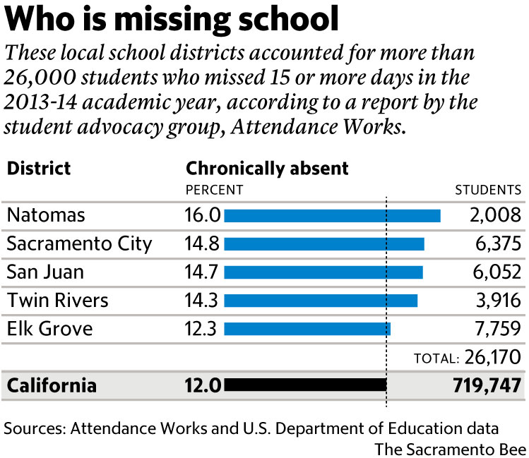

Sixth Grade Mystery Data

Look at the graphs on the next pages. Each graph shows something about a classroom of sixth graders.

- Which of the five graphs do you think shows:
- the number of cavities the sixth graders have?

- the number of people in the sixth graders’ families?

- the ages of the sixth graders’ mothers?

- the heights of the sixth graders in inches?

- Why do you think the graph you picked for d is the one that shows the heights of sixth graders? Why do you think the other graphs don’t show the sixth graders’ heights?

- One of the graphs was not selected to answer question one above. What do you think this data display might represent? Why?
Sixth Grade Mystery Data

Graph 1

 |  |  |  | x
 |  |  | x | x
 |  |  | x | x | x
 |  |  | x | x | x
 |  |  | x | x | x
 |  | x | x | x | x | x
 |  | x | x | x | x | x |  | x | x
0 | 1 | 2 | 3 | 4 | 5 | 6 | 7 | 8 | 9

Graph 2

 |  |  |  |  |  |  | x |  |  | x
 |  |  |  | x |  | x | x |  | x | x |  | x |  | x
x |  | x | x | x | x | x | x | x | x | x | x | x | x | x | x
58 | 59 | 60 | 61 | 62 | 63 | 64 | 65 | 66 | 67 | 68 | 69 | 70 | 71 | 72 | 73

Graph 3

 |  |  |  |  |  | x | x | x |  | x
 |  | x | x |  | x | x | x | x | x | x
x |  | x | x | x | x | x | x | x | x | x | x | x
46 | 47 | 48 | 49 | 50 | 51 | 52 | 53 | 54 | 55 | 56 | 57 | 58

Sixth Grade Mystery Data

Graph 4

x
x
x |  |  |  | x
x |  |  |  | x
x | x |  | x | x
x | x | x | x | x
x | x | x | x | x | x | x | x
0 | 1 | 2 | 3 | 4 | 5 | 6 | 7 | 8

Graph 5

 |  |  |  |  |  |  | x
 |  |  |  |  |  |  | x |  |  | x
 |  |  | x |  |  | x | x |  |  | x |  |  |  |  |  | x
x | x |  | x | x |  | x | x | x | x | x | x | x |  | x |  | x |  | x |  |  |  | x
26 | 27 | 28 | 29 | 30 | 31 | 32 | 33 | 34 | 35 | 36 | 37 | 38 | 39 | 40 | 41 | 42 | 43 | 44 | 45 | 46 | 47 | 48

Graph A
Ice Cream Preferences

Vanilla

Chocolate

Mint Chip

Cookies &
Cream
Other

= 1 student

Graph B

Number of Cavities
X
X
X
X X
X X X
X X X X X
X X X X X X X

0 1 2 3 4 5

Graph C
Relationship of Height to Age
Height in Inches

75 • •
70 • • • • • • •
65 • • • • • •
60 • • • • • • • •
55 • • • • • • •
50 • • • • •
- • • • •
40 • •
35 •
30
25
20

7 8 9 10 11 12 13 14 15 16 17 18 19 20
Age in Years

