AR Remediation Plan – Data Representation and Interpretation

Histograms

STRAND: Probability and Statistics

STRAND CONCEPT: Data Representation and Interpretation

SOL 7.9a

Remediation Plan Summary
Students will analyze data by sorting, classifying, and displaying it in frequency distributions and histograms.

Common Misconceptions
Students often confuse a bar graph for a histogram. Students have a difficult time making the bins at equal intervals

Materials
- Compare a bar graph to a histogram
- Cubes
- Hand Full worksheet
- Attributes of Frequency Distributions and Histograms
- Weight of Guide Dogs Enrolled in Training Programs
- Blank Histogram templates

Introductory Activity
Display the compare a bar graph and a histogram. Discuss the similarities and differences between the two graphs.

Plan for Instruction
- Hand out the Attributes of Frequency Distributions and Histograms sheet. Discuss how to gather data in a frequency table and then how to design a histogram.
- Place cubes in a paper bag. Distribute the Hand Full worksheets. As a whole group take turns estimating how many cubes each student can grab. Have everyone in the group take a turn estimating.
- Work together as a whole group filling in the “Hand Full” Estimate frequency table. As a whole group work together to take the data from the frequency table to make a histogram. Work together to find the bin size and the frequency spread.
- Next have everyone take a turn actually pulling cubes out of the bag. Record the actual grabs. Place all cubes back in the bag after each pull.
- Once all student grabs have been recorded, have students work in small groups to fill out the “Hand Full” Actual frequency table and create a histogram of the actual data. Teacher should be walking around monitoring and assisting students.

Pulling It All Together (Reflection)
Have each student create a frequency table and histogram of the weight of guide dogs enrolled in training programs and the blank histogram template. Students will create their own histograms and frequency tables using the data.

Note: The following pages are intended for classroom use for students as a visual aid to learning.

Bar Graph versus Histogram

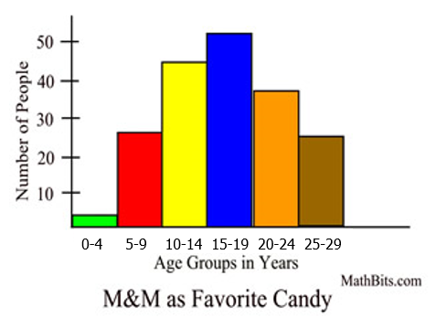
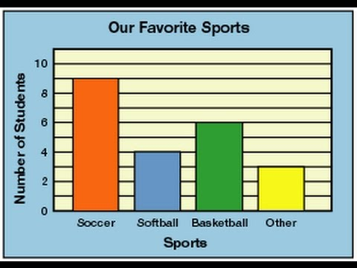

- How are the two graphs the same? How are
they different?
2. How are the bars different in the graphs?
3. What do you about the height of the bars in the bar graph and in the histogram?

Today we will be making histograms, not bar graphs. We need to work on the understanding of the data in the histogram.
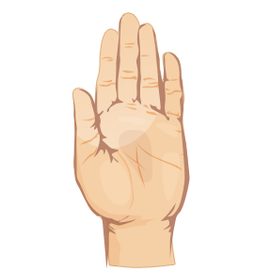
Hand Full

Number of Objects Grasped

Student | Estimate | Actual

Frequency Distribution Estimate
Interval | Frequency
0-4
5-9
10-14
15-19
20-24
25-29
30-34
Frequency Distribution Actual
Interval | Frequency
0-4
5-9
10-14
15-19
20-24
25-29
30-34

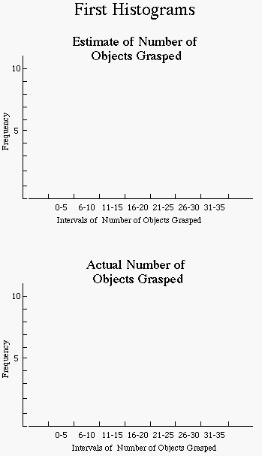
0-4 5-9 10-14 15-19 20-24 25-29 30-34
0-4 5-9 10-14 15-19 20-24 25-29 30-34

Attributes of Frequency Distributions and Histograms

- A frequency distribution is a chart that shows the number of times that a particular measure or observation occurs.

• The chart contains two columns. The first column lists all the measures (from highest to lowest) or observations. The second column gives the frequency, or number of times, that the measure or observation occurred.

• Usually the first step in making a frequency distribution is to list the possible measures or observations (first column) and then go through the data and make tally marks (second column) every time a measure or observation occurs. Then the number of tally marks for each measure or observation is counted to find the frequency. Measures in a frequency distribution are usually grouped into intervals if the difference between the highest and lowest measures is 20 or greater.

• To decide the size of an interval, the range (the difference between the highest and lowest measures) is divided by the desired number of intervals. If the quotient does not come out even, statisticians usually round it to the nearest odd number.

- A histogram is a special type of bar graph in which the categories are equal ranges (intervals) of numbers and there are no spaces between the bars. The height of each bar is the numerical count of numbers in the range or interval.

• The center of the horizontal axis is usually the midpoint of the intervals. It is customary to start with the lowest value on the left and proceed to the right with as many intervals as are necessary to include all the data. The horizontal axis does NOT need to begin at zero. An empty interval should be left at the lower and upper ends of the axis.

• The vertical axis is the frequency of numbers in an interval. The vertical axis is marked off beginning with zero at the bottom and proceeding to the highest frequency. When statisticians graph frequency distributions, they use the “three-quarter-high rule” which means that the height of the highest bar is approximately three-fourths of the length of the horizontal axis. This rule prevents personal bias from influencing the height of the vertical axis. The vertical axis should be labeled “frequency” and the horizontal axis should be labe led to describe what is being measured.

• The graph should have a descriptive title.

Weight of Guide Dogs Enrolled in Training Programs

Weight (lb)

81 | 88 | 57 | 82 | 70 | 85
71 | 51 | 82 | 77 | 79 | 77
83 | 80 | 54 | 80 | 81 | 73
59 | 84 | 75 | 76 | 68 | 78
83 | 78 | 55 | 67 | 85 | 79

Frequency Table of Weight of guide dogs
Weight intervals | Frequency

Title
________________________________________________

Frequency
Title

