AR Remediation Plan – Data Representation and Interpretation

Graph Match

STRAND: Probability and Statistics

STRAND CONCEPT: Data Representation and Interpretation

SOL 5.16a,b,c; 6.10b; 8.13a

Remediation Plan Summary
Students will understand how to choose a graphical method that best displays a set of data.

Common Errors and Misconceptions
Students have a difficult time understanding which type of graph best represents a set of data. They need to compare and contrast data sets with different representations. Scatterplots are not introduced until 8th grade. Teachers can substitute the scatterplots in this lesson with other types of graphs if this lesson is used with younger students.

Materials
- Introduction Graphs
- Sets of Data- one copy for each group of 2 or 3 students
- Data graphs- one set for each group of 2 or 3 students
- Reflection

Introductory Activity
Display the introductory graphs. Ask the students “How is each graph different? What do you notice about the data? What two variables are you comparing in the scatterplot? What is the line plot graphing? What is the stem-and-leaf graphing? Do you think the scatterplot data would be displayed as nicely in a line plot or a stem-and-leaf? Today we are going to examine data and decide which graph best represents the data.

Make sure you discuss the purpose of each graph. A line plot only graphs numbers no words, A stem and leaf graphs large amount of data and separates it into place value such as tens and ones. A scatterplot is comparing 2 pieces of data looking for trends such as temperature and ice cream sales, height and weight, height and shoe size. Circle graphs use the data as fractional amounts. The circle is divided into the fractional amount to represent each piece of data.

Plan for Instruction
- Give each pair of students the sets of data sheet. Discuss the data with the group and ask the students which data they think will be best graphed as a scatterplot? If they don’t understand go back to the introduction and examine the scatterplot. Look at what is being graphed on a scatterplot. Make sure they know that it is 2 different pieces of data number of visitors to the beach and temperature in Fahrenheit. Ask them which set of data has 2 different variables?
- Next ask which data will best be represented as a line plot and which as a stem –and-leaf? Have the students discuss in pairs which type of graph will best represent the data.
- Hand out the 3 data graphs sheets, one set per pair or small group. Have them look over the data and the graphs and match the correct graph to the data. Ask them to discuss which graph they wanted as a scatterplot and which graph accurately depicts the data. The students are to work together to examine data and graphs.
- Ask the students why they think each data set is depicted using that graphic representation? Why do they want to use a particular graph to represent the data? Make sure they justify their reasoning.

Pulling It All Together (Reflection)
Have students complete the reflection sheet.

Note: The following pages are intended for classroom use for students as a visual aid to learning.
Virginia Department of Education 2018

Introductory Graphs

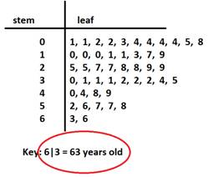
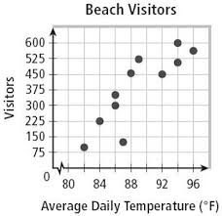
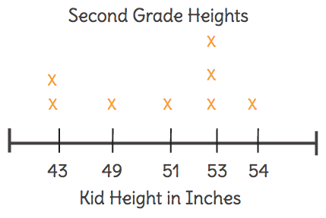
Scatterplot
Stem-and-Leaf
Line Plot

Sets of Data

Shoe Size | Height in inches
5 | 63
4 | 60
12 | 77
8 | 66
9 | 70
7.5 | 65
6.5 | 65
11.5 | 67
10.5 | 74
7 | 61
6.5 | 64
9 | 72
4 | 65
8 | 69
4 | 62
6 | 66
10.5 | 71
11 | 71
Number of Brothers and Sisters | Number of Children
0 | 5
1 | 8
2 | 12
3 | 6
4 | 7
5 | 2
6 | 4
Greater than 6 | 1

Portland Oregon July Temperatures in Fahrenheit

75 º | 69 º | 76 º | 82 º | 86 º | 82 º | 78 º
86 º | 70 º | 76 º | 85 º | 93 º | 89 º | 89 º
97 º | 94 º | 90 º | 81 º | 70 º | 77 º | 78 º
92 º | 92 º | 92 º | 94 º | 94 º | 89 º | 88 º
86 º | 87 º | 93 º

Data Graphs

6
7
8
9
Stem
Leaf
9
0 0 5 6 6 7 8 8
1 2 2 5 6 6 6 7 8 9 9 9
0 2 2 2 3 3 4 4 4 7
Key
7 5 = 76

STEM
LEAF
0
1
1 2 4 5 6 7 8
2
Key
0 2 = 2

0 1 2 3 4 5 6 Greater
Than 6
X
X
X
X
X
X
X
X
X
X
X
X
X
X
X
X
X
X
X
X
X
X
X
X
X
X
X
X
X
X
X
X
X
X
X
X
X
X
X
X
X
X
X
X
X

Graph Reflection

Name ___________________________

- What types of data can you graph using a line plot?

- How many variables do you compare on a scatterplot? Why do you use a scatterplot?

- Why types of data work well with a stem and leaf? Why do you separate into stem-and-leaves?

