AR Remediation Plan – Data Representation and Interpretation

Circle Graphs

STRAND: Probability and Statistics

STRAND CONCEPT: Data Representation and Interpretation

SOL 6.10a

Remediation Plan Summary
Students will use the data set given construct circle graphs.

Common Errors and Misconceptions
Students have a difficult time reading circle graphs. They need more practice with converting data to fractional pieces in a circle graph.

Materials
- Population of English Speaking People
- rulers,
- construction of a circle graph activity sheet (Favorite Amusement Park Rides),
- circle graph construction assessment activity sheet (Favorite Chocolate Treat)

Introductory Activity
Display the “Population of English Speaking People” graph, work with the students to estimate the angle measures and answer the questions.

Plan for Instruction
- The instructor describes the attributes of a circle graph and demonstrates how fractional pieces are determined from the data
- The instructor provides a set of data (Favorite Amusement Park Rides Activity Sheet) for the students to generate a circle graph. Students work in pairs to construct the graph, share their results with another pair of students, and assess whether or not they have included all the attributes of a well-constructed circle graph.

Pulling It All Together (Reflection)
The instructor provides a set of data (Favorite Chocolate Treat Activity Sheet) for each student to generate a circle graph. Students work individually to construct the graph and self-assess whether or not they have included all the attributes of a well-constructed circle graph.

Note: The following pages are intended for classroom use for students as a visual aid to learning.

Virginia Department of Education 2018

Population of English Speaking People

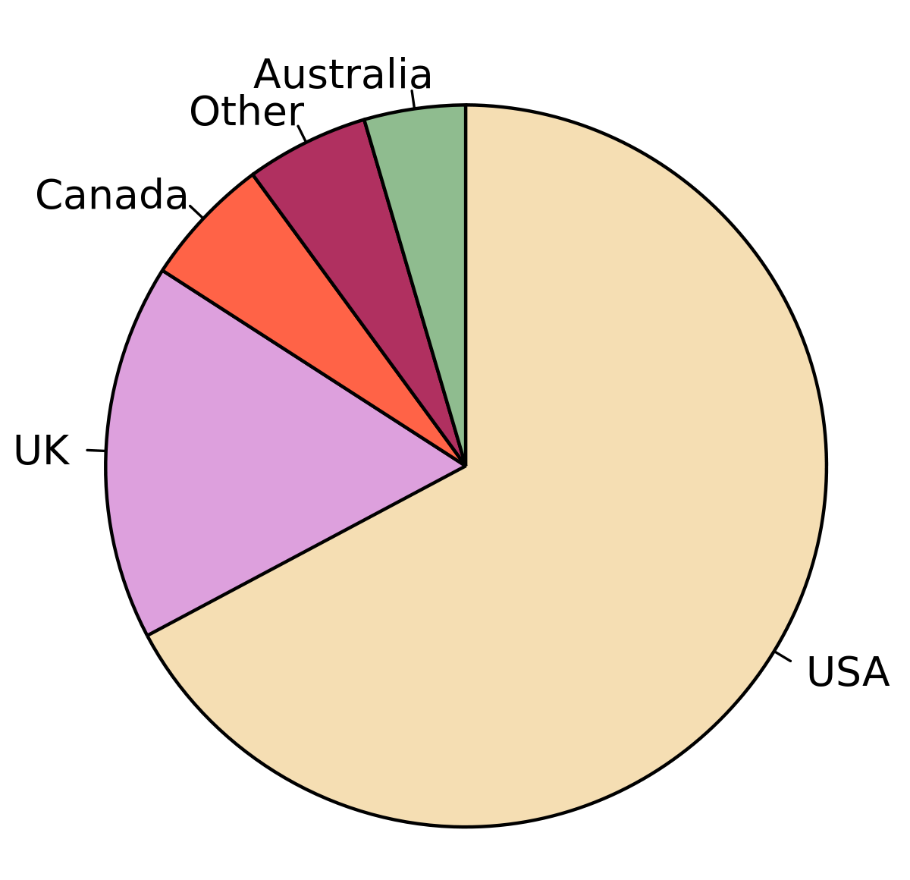

- Looking at the graph, can you tell what is the largest country? How do you know that?
- What is the second largest country?
- Can you guess a fractional amount of the USA? Is it larger than half, how do you know?
- How are circle graphs and fractions related?
FAVORITE ICE CREAM

Flavor | Number of Students | Fraction
Strawberry | 3 | 3/24 or 1/8
Chocolate | 6 | 6/24 or ¼
Vanilla | 12 | 12/24 or ½
Chocolate Chip | 3 | 3/24 or 1/8
Total | 24 | 24/24 or 1

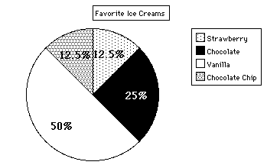

Favorite Amusement Park Rides
Use the information in the chart to make a circle graph of the favorite amusement park rides of the students surveyed.

Favorite Ride | Number of students | Fraction
Sea Monster | 16
Twizzler | 12
Super Spin | 8
Water Log | 6
Wall Climber | 6
Total

Circle Graph

Explain what the graph tells you about the students’ preferences for the amusement park rides?
Favorite Chocolate Treat
Use the information in the chart to make a circle graph of the favorite chocolate treat of the students surveyed.
Favorite Chocolate Treat | Number of Students | Fraction
Chocolate Cake | 6
Chocolate Ice Cream | 12
Chocolate Chip Cookie | 20
Chocolate Candy | 16
Chocolate Milk | 6
Total

Circle Graph

Explain what the graph tells you about the students’ preferences for chocolate treats?

