*AR Remediation Plan – Data Representation and Interpretation*

# Circle Graph Pieces

## STRAND: Probability and Statistics

## STRAND CONCEPT: Data Representation and Interpretation

## SOL 6.10a

### Remediation Plan Summary

Students will analyze fraction, percent, and circle graphs.

### Common Misconceptions

Student who have difficulty understanding fractions of a circle have a difficult time seeing the fractional amount in a circle graph. Students need more practice understanding fractions to be able to apply them to a circle graph.

### Materials

* Cutting an Apple Pie sheet
* Concept Activity Sheets of circle graphs (THIRDS, FOURTHS, FIFTHS, SIXTHS, and EIGHTHS), each marked or to be marked and shaded (or colored) with a fractional part, and percent.
* Concept Understanding Assessment Activity Sheet: Mystery Circle Graphs

### Introductory Activity

Display the Cutting an Apple Pie sheet. Have a discussion about the pie and the questions relating to the pie.

### Plan for Instruction

1. The students are each given an activity sheet to complete, followed by the instructor’s questions related to the shading completed (THIRDS, FOURTHS, FIFTHS).
2. The students shade a part of the interiors for SIXTHS . The instructor’s questions about equivalents follow.
3. The students shade a part of the interiors for EIGHTHS . The instructor’s questions about equivalents follow.

### Pulling It All Together (Reflection)

The students use information from their THIRDS, FOURTHS, FIFTHS, SIXTHS, and EIGHTHS Activity Sheets to assist in completing the Mystery Circle Graphs activity.

**Note: The following pages are intended for classroom use for students as a visual aid to learning.**

**Cutting an Apple Pie**

**My family loves apple pie but we don’t want the same amount so we cut the pie into different sizes. Look at the pie and decide what fraction of the pie each person is eating.**

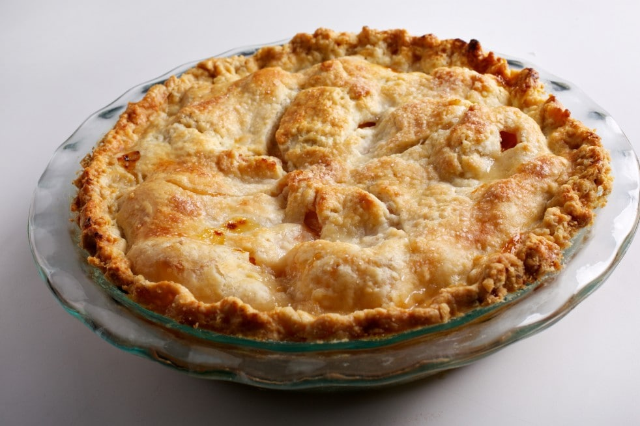

1

2

3

4

5

6

7

1. What number slice looks like the largest slice? Are there anymore that look about the same? What fraction do you think it is?
2. What number slice looks like the smallest? What fractional amount do you think it is? Are there any other slices that look similar in size?
3. Are any of the pieces about the same size? What fraction do you think they are?

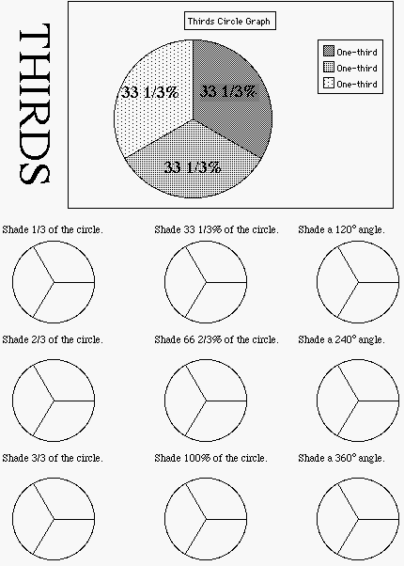

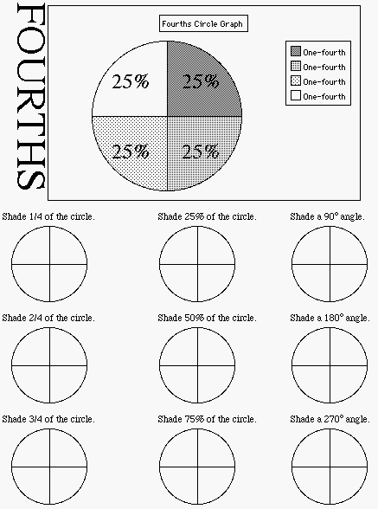

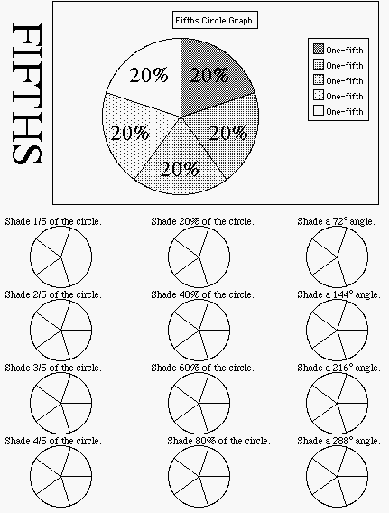

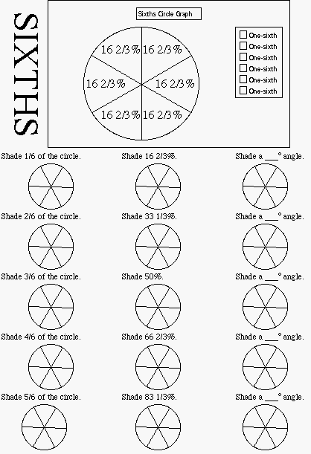

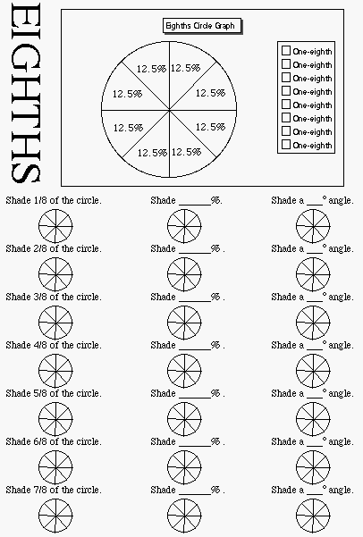

**Mystery Circle Graphs**

For each sector in the circle graph, find the fractional part represented, the percent of the whole circle, and the measure of the central angle.

|  |  |  |  |
| --- | --- | --- | --- |
| Fraction |  |  |  |
| Percent |  |  |  |



|  |  |  |  |
| --- | --- | --- | --- |
| Fraction |  |  |  |
| Percent |  |  |  |



|  |  |  |  |
| --- | --- | --- | --- |
| Fraction |  |  |  |
| Percent |  |  |  |

|  |  |  |  |
| --- | --- | --- | --- |
| Fraction |  |  |  |
| Percent |  |  |  |

