# AR Remediation Plan – Proportional and Additive Relationships; Slope; Linear Functions

### Identifying Slope and Y-Intercept

### STRAND: Patterns, Functions, and Algebra

### STRAND CONCEPT: Proportional and Additive Relationships; Slope; Linear Functions

### SOL 8.16a, b

#### Remediation Plan Summary

Students will recognize and describe the graph of a linear function with a slope that is zero, positive or negative. Students will identify the slope and *y*-intercept of a linear function given a table of values, a graph, or an equation in *y* = *mx* + *b* form.

#### Common Errors and Misconceptions

* Students may confuse lines with positive slope and lines with negative slope.
* Students may state that the slope is 3*x* versus just 3 given *y* = 3*x* - 5 for example.
* Students may state that the *y*-intercept is 5 given *y* = 3*x* - 5 for example, not recognizing that subtraction symbol is representative of a negative *y*-intercept.

#### Materials

* Station Activity – Slope and *y*-intercept

#### Introductory Activity

Have students work with a shoulder partner to discuss the following situations representing a linear rate of change. Then have the students talk and determine an equation that might represent the weight gain for a baby blue whale. Have a whole class discussion about the meaning of the slope and *y*-intercepts related to each situation. Be sure that students are comparing and contrasting each situation.

**Match each species in column A to its growth rate equation in Column B. Then create an equation for the missing match.**

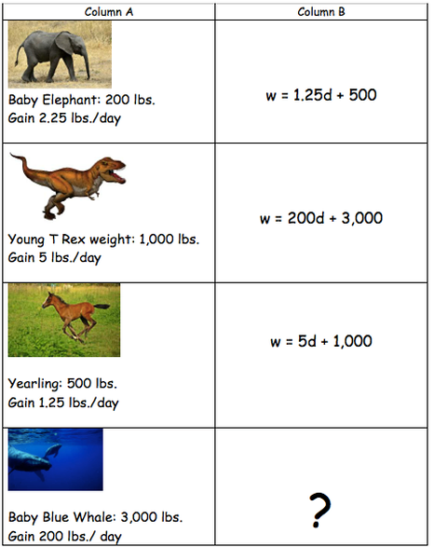

#### <https://www.mathhooks.com/functions>

#### Plan for Instruction

1. Students may benefit from a brief discussion of the meaning of linear rate of change or slope. Students who have learned about rate of change in proportional relationships may be familiar with how ratio tables can represent the rate of change. Use the animal growth activity to help students think about various rates of change and *y*-intercept. Ask students to identify a real world situation in which the rate of change is negative.
2. Have the group divide into small groups to participate in the Station Activity – Slope and *y*-intercept.
3. Debrief the station activity as a whole group and ask students to justify how they were able to find the slope and *y-*intercept in the examples provided.

#### Pulling It All Together (Reflection)

Exit Ticket:

Write the equation of a line in *y* = *mx* + *b* form. Determine the slope and *y*-intercept. Graph the line and describe the slope as positive, negative or zero. Explain how you know.

**Note: The following pages are intended for classroom use for students as a visual aid to learning.**

Virginia Department of Education 2018

**Station 1**

Determine whether the line has a slope that is positive, negative or zero. Circle the correct description given the graph of each line.

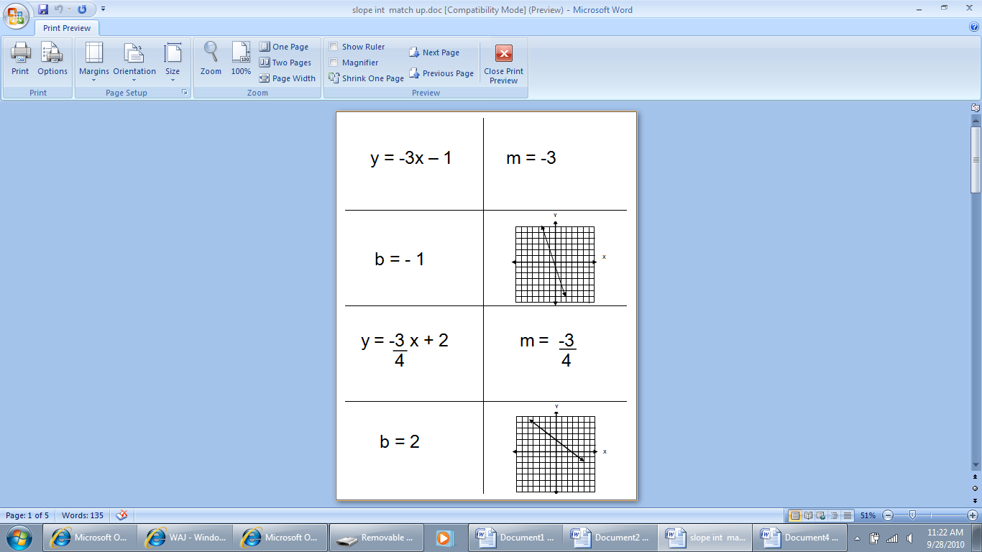

1. POSITIVE NEGATIVE ZERO



1. POSITIVE NEGATIVE ZERO

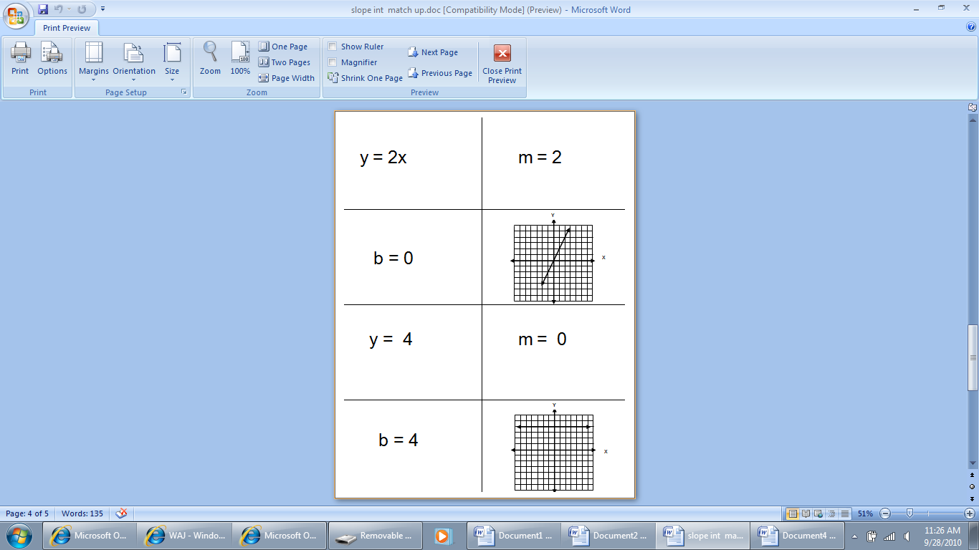

1. POSITIVE NEGATIVE ZERO



1. POSITIVE NEGATIVE ZERO

**Station 2**

Identify the slope and *y-*intercept of each linear function.

1.  slope (*m*) = _______ *y*-intercept: ­­­­­________
2.  slope (*m*) = _______ *y*-intercept: ­­­­­________
3.  slope (*m*) = _______ *y*-intercept: ­­­­­________
4.  slope (*m*) = _______ *y*-intercept: ­­­­­________
5.  slope (*m*) = _______ *y*-intercept: ­­­­­________

**Station 3**

Identify the slope and *y-*intercept of each linear function.

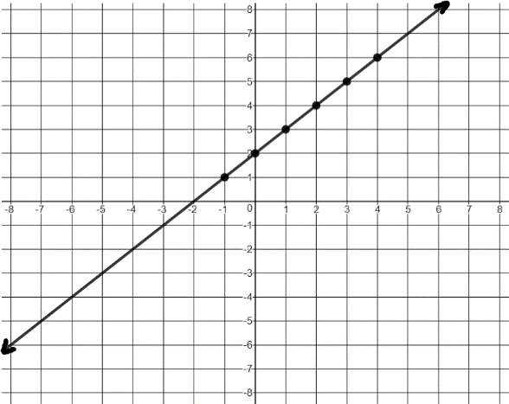

1. slope (*m*) = _______

*y*-intercept: ­­­­­________

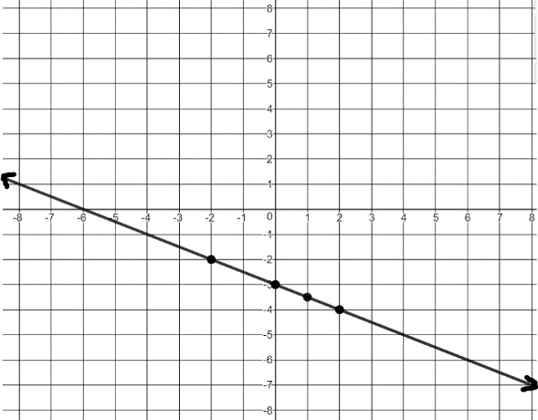

1. slope (*m*) = _______

*y*-intercept: ­­­­­________

1. 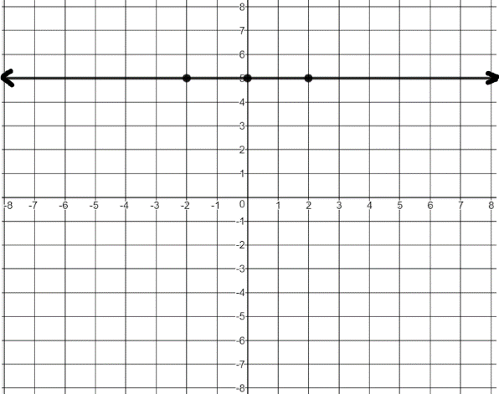

slope (*m*) = _______

*y*-intercept: ­­­­­________

**Station 4**

Identify the slope and *y*-intercept of the linear function represented by the table of values.

|  |  |
| --- | --- |
| **x** | **y** |
| -2 | -3 |
| -1 | -1 |
| 0 | 1 |
| 1 | 3 |
| 2 | 5 |

slope (*m*) = _______

*y*-intercept: ­­­­­________

|  |  |
| --- | --- |
| **x** | **y** |
| -2 | 5 |
| -1 | 3 |
| 0 | 1 |
| 1 | -1 |
| 2 | -3 |

slope (*m*) = _______

*y*-intercept: ­­­­­________

|  |  |
| --- | --- |
| **x** | **y** |
| -2 | -7 |
| -1 | -7 |
| 0 | -7 |
| 1 | -7 |
| 2 | -7 |

slope (*m*) = _______

*y*-intercept: ­­­­­________