# AR Remediation Plan – Proportional and Additive Relationships; Slope; Linear Functions

Slope – Rate of Change in a Proportional Relationship

## STRAND: Patterns, Functions, and Algebra

## STRAND CONCEPT: Proportional and Additive Relationships; Slope; Linear Functions

## SOL 7.10a,b

### Remediation Plan Summary

Students determine slope as a rate of change in a proportional relationship between two quantities; write equations in the form *y* = *mx* to represent a proportional relationship; and graph lines representing a proportional relationship using slope and an ordered pair or an equation.

### Common Errors and Misconceptions

* Students, when using slope triangles, may incorrectly invert the relationship as a constant ratio of versus  .
* Students may not recognize that the constant multiplier in a table of values representing a proportional relationship is the slope.

### Materials

* Warm Up activity sheet
* Activity pages

### Introductory Activity

Have students complete the “Warm-up” activity without the use of a ratio table. Students should be encouraged to use various strategies for finding a solution and be encouraged to justify their answers. Engage students in a discussion of what strategies they used. If a student does not use a ratio table, encourage a discussion around what that might look like. Then introduce the ratio table at the end of the activity and have students complete it with a partner. Ask students to talk about the unit rate in this situation and how they worked to determine the money earned for completing one chore.

### Plan for Instruction

1. Discuss with students as a whole class what it means for two quantities to have a proportional relationship. Is the relationship from the introductory activity of chores and money earned to buy a video game an example of a proportional relationship? Ask students to provide some other examples. Encourage students to use various representations, such as verbal description of practical situations, equations, ratio tables, and graphs.
2. Explain the concept of a double number line. Encourage students to use a double number line to represent the relationship between chores and money earned from the warm-up activity.

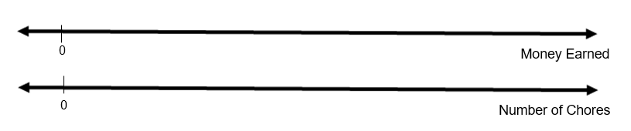

1. Write the equation y = 3x on the board. Ask students to create a ratio table to represent the relationship. Encourage students to think of unique pairs of values that would correctly fill in the ratio table. Compare values as a whole class by completing a table. Have students determine what value could be multiplied by x to obtain y in each ordered pair. Discuss that this represents the unit rate, but also the slope, or rate of change, between y and x. Ask students to create a practical situation that could model this relationship (e.g. there are 3 dogs for every 1 cat at the animal shelter; Tom walks 3 miles in 1 hour). Use a graph to represent ordered pairs that satisfy the relationship. Discuss a few of the contextual situations posed by the students to determine if the graph of those relationships could be represented by only ordered pairs (e.g. 3 dogs for every 1 cat since there cannot be fractional portions of dogs or cats) versus using a straight line (e.g. Tom walks 3 miles in 1 hour). Point out the slope triangles that can be formed from the graph of the ordered pairs.
2. Write the equation  on the board. Ask students to create a ratio table to represent the relationship. Encourage students to think of unique pairs of values that would correctly fill in the ratio table and to find the slope, or rate of change, in the proportional relationship. Compare values as a whole class by completing a table. Ask students to create a practical situation that could model this relationship. Use a graph to represent ordered pairs that satisfy the relationship. Discuss a few of the contextual situations posed by the students to determine if the graph of those relationships could be represented by only ordered pairs versus using a straight line.
3. Ask students to find an equation for a proportional relationship if the slope is 2 and passes through the point (4, 8). Have students create a graph that represents this relationship. Encourage students to draw slope triangles to represent the slope relationship in the graph.
4. Have the two students work together to think of an equation that represents a proportional relationship, create a ratio table for the equation, find the slope, create a practical situation that could model the relationship, and create a graph that models the practical situation. Have each pair of students share with the whole group. Have students discuss what they notice that all of the equations have in common. What does the ordered pair (0, 0) represent for each practical situation?
5. Have the students complete the Activity pages.

### Pulling It All Together (Reflection)

Exit Ticket: Complete the following statement using what you learned from the lesson today.   
  
The slope, or rate of change in a proportional relationship can be found by……..

**Note: The following pages are intended for classroom use for students as a visual aid to learning.**

Virginia Department of Education 2018

**Name:**

**Warm-up**

Thomas would like to buy a video game that costs $55. He has not saved any money toward the purchase of the game, but his parents are willing to pay him to do some chores around the house to earn the money. Thomas’ parents will him $5 for every 4 chores that he completes. Thomas can also earn money for completing single chores as well.

\**Teacher Note: Allow students to find a solution to the problem above using any method that they choose, but that they must justify their answer. Then introduce the ratio table below and ask students to complete it and be able to explain how they were able to correctly find the missing values.*

Complete the ratio table below to show how many chores Thomas would have to do in order to save enough money to buy the game.

| *x* chores | 1 |  | 4 | **8** |  | **20** |  |  |  |
| --- | --- | --- | --- | --- | --- | --- | --- | --- | --- |
| *y* money earned |  | $2.50 | **$5** |  | **$18.75** |  | $37.50 | $50 | $55 |

**Activity Work 1**

**Name Date**

1. Mrs. Kelley buys walnuts in bulk at the store that cost $2.00 per pound. Create a table that could represent Mrs. Kelley’s cost per pound of walnuts that she purchases. Graph those points on the graph and create a rule that represents the relationship.

Cost ($)

|  |  |
| --- | --- |
| Walnuts (lbs.) | Cost ($) |
|  |  |
|  |  |
|  |  |
|  |  |

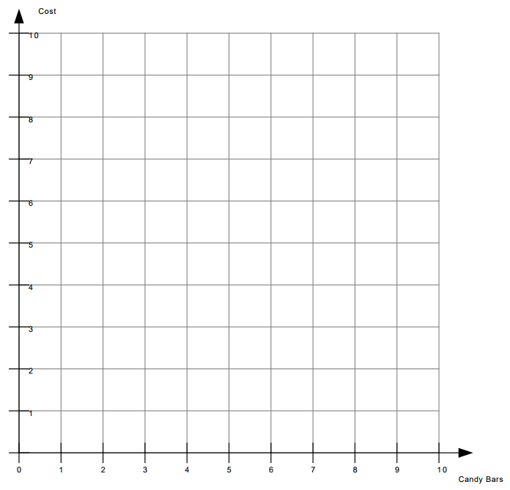

Walnuts (lbs.)

*y* = _____ *x*



Cost ($)

0



Walnuts (lbs.)

0

**Activity Work 2**

1. An elm tree seed is planted and the tree grows at a constant rate of 2.25 feet per month. Create a table that could represent the tree’s height. Graph those points on the graph and create a rule that represents the relationship.

|  |  |
| --- | --- |
| Number of Months | Height (ft) |
|  |  |
|  |  |
|  |  |
|  |  |

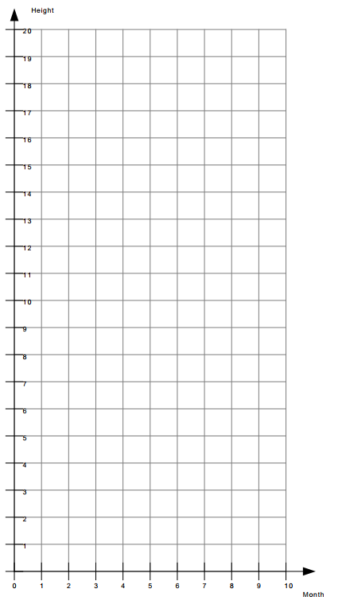

*y* = _____ *x*



Height

0



Month

0

**Activity Work 3**

1. The species of turtle can swim at a constant speed. The table represents the distance a turtle can travel over time. Graph those points on the graph and create a rule that represents the relationship.

|  |  |
| --- | --- |
| Time (hrs.) | Distance (mi.) |
| 2 | 0.8 |
| 3 | 1.2 |
| 4 | 1.6 |
| 5 | 2.0 |

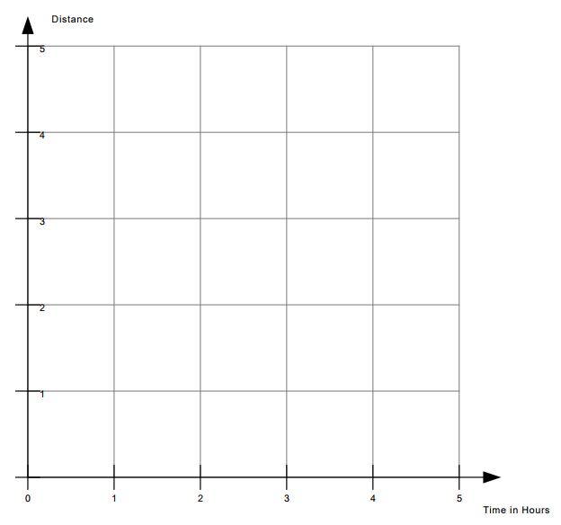

y = _____ x



Distance

0



Time in Hours

0