# AR Remediation Plan – Solving Inequalities

### Representing and Solving Practical Situations with Inequalities

### STRAND: Patterns, Functions and Algebra

### STRAND CONCEPT: Solving Inequalities

### SOL: 6.14ab, 7.13

### Remediation Plan Summary

Students will represent and solve one and two-step inequalities involving practical situations.

#### Common Errors and Misconceptions

* Students have difficulty understanding, writing, and graphing the inequality both ways

(i.e. m<6 and 6>m).

* Students have trouble making sense of such terms as “at least” and “at most.”
* Students use “tricks” to help them figure out which direction to shade the number line without conceptually understanding the meaning of the inequality.

#### Materials

* Warm-up sheet
* Individual student white boards
* Dry-erase markers
* Cut-out Inequality Task Cards
* Inequality Task Cards Answer sheet
* Inequalities practice sheet

#### 

#### Introductory Activity

* Ask the students to complete the attached warm-up about equations with a partner.
* Discuss the answers as a whole group.

***Plan for Instruction***

1. Review the difference between equations and inequalities with the idea of a balance/scale. If a scale is presented with objects on both sides and they are balanced, then the students should understand that this means that the two sides are equal; however, if one side goes down or up, then that represents an inequality.
2. Review how to write an inequality. First review how to write an inequality with the variable first, and then practice with the students how to write equivalent inequalities with the number written first (For example c <5 is equivalent to 5>c).
3. Ask students what you need to do when graphing inequalities. They should remember that you need to shade toward the side of the possible solutions and add an arrow. Review how to solve this inequality: x + (-3) < 6. The solution is x<9. The final graph should look like this for x<9:

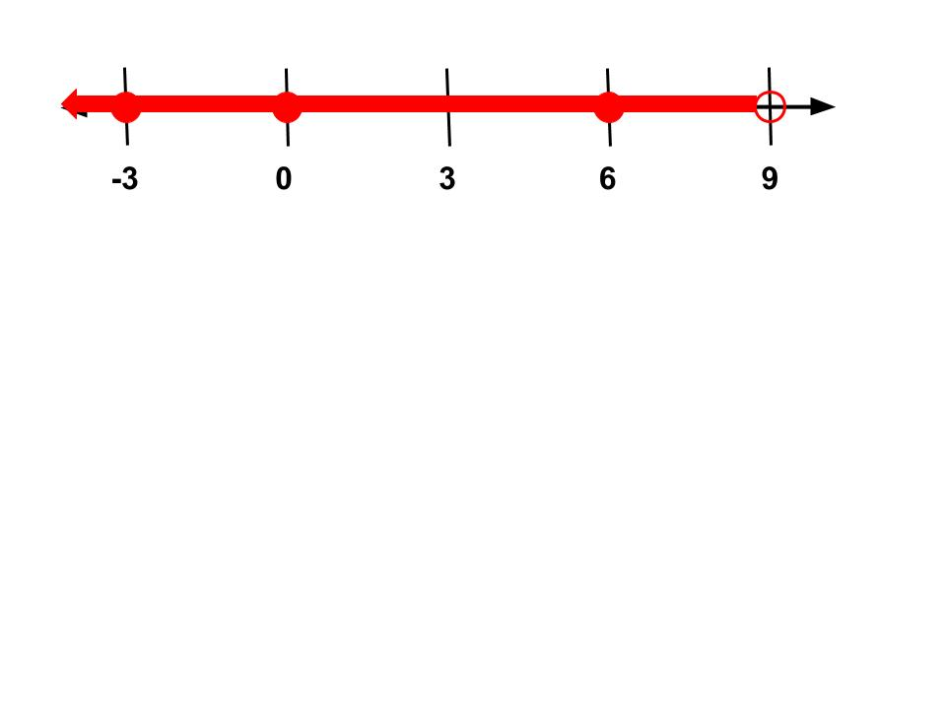

1. Have students write down possible solutions for x + (-3) < 6 and check to see whether their answers are correct by using the substitution property. For example, if they say that 8 is a possible solution, rewrite the inequality x + (-3) < 6 and substitute 8 for *x*. Rewrite it as 8 + (-3) < 6, solve it, and see whether the statement is true. In this case, 5 is less than 6, so 8 is a correct solution. Accept a variety of responses from the students and try each of them in the same manner.
2. With their shoulder partner, ask students to think about some real life examples of inequalities. Discuss such terms as “at most” and “at least” and other words/expressions that represent inequalities. Have them each write their example on a white board, with the words, inequality, and graph.
3. Have students share out their examples with the whole group.
4. Review how to solve one and two-step inequalities. Discuss how the steps for solving inequalities are the same as they are for solving equations, with the exception of one situation: When multiplying or dividing both sides of the inequality with a negative. Review this concept with the following questions and discussion:

4 < 8. Is this true?

Add 2 to both sides (now 6 < 10). Is it still true? YES

Subtract 2 from both sides (now 2 < 6). Is it still true? YES

Subtract 9 from both sides (now –5 < –1). Is it still true? YES

Multiply by 3 on both sides. (now 12 < 24). Is it still true? YES

Multiply by ½ on both sides (now 2 < 4). Is it still true? YES

Divide by 4 on both sides (now 1 < 2). Is it still true? YES

Multiply by –5 on both sides. (now –20 < –40). Is it still true? NO

Divide by –2 on both sides, (now –2 < –4). Is it still true? NO

* + - 1. Can you make up a rule about multiplying and dividing by negatives?

1. Give students the inequality −3*x* + 6 ≥ 9 to solve on their whiteboard. Observe how the students solve this inequality based on the previous discussion. Have the students solve the problem again if they did not get it correct the first time, flipping the sign when they divide by –3. After they have solved the inequality, have them graph their answers on their number lines. Repeat with more examples that require changing the sign (e.g., 13 < –6x+ 1, –3*x* + 5 ≤ 20)
2. After the students have had sufficient review with representing, solving, and graphing one and two-step inequalities, have them complete the task card activity. Give one task card to each student to solve and become the “expert”. The teacher can differentiate by strategically giving out the task cards. After each student completes his/her task card correctly, the teacher initials his/her answer sheet.
3. Students then take turns giving each other their task cards to complete, initialing each other’s answer sheet. The students are “experts” on their questions and are expected to help guide other students who are having difficulty.
4. The activity is complete when all task cards have been answered by everyone.
5. This lesson may take two days to complete, with the review from steps #1-8 on the first day, and the task card activity on the second day.

#### Pulling It All Together (Reflection)

Provide students with a graphed solution of an inequality on a number line, and have them write the inequality indicated by the graph, and at least three solutions that are graphed. Ask them to create a real life situation that can result in the same solution.

For extra practice the students can complete the inequality practice sheet.

**Note: The following pages are intended for classroom use for students as a visual aid to learning**

Virginia Department of Education 2018

**Warm-up**

* Solving an equation means…
* To solve an equation algebraically, we use operations to both sides. (For example, we use addition to “undo” subtraction.)
* An equation has how many solutions?
* Jeffrey solved the equation below. Examine his work and explain the error he made in solving the equation.

y - (-4) = 6

+ 4 + 4

y = 10

**Warm-up**

* Solving an equation means…
* To solve an equation algebraically, we use operations to both sides. (For example, we use addition to “undo” subtraction.)
* An equation has how many solutions?
* Jeffrey solved the equation below. Examine his work and explain the error he made in solving the equation.

y - (-4) = 6

+ 4 + 4

y = 10

Inequality Task Cards

|  |  |
| --- | --- |
| 1. Solve and graph the inequality:  k – 5 < 6 | 2. Solve and graph the inequality:  -2r - 4 ≤ -6 |
| 3. Solve and graph the inequality:  h > 4 | 4. Solve and graph the inequality:  -6x – 6 ≤ 30 |
| 5. Solve and graph the inequality:  2p – 8 ≥ 2 | 6. Solve and graph the inequality:  15 +  x > 5 |
| 7. For which two symbols would you use a closed circle when graphing? **Why**? | 8. For which two symbols would you use an open circle when graphing? **Why**? |
| 9. Write an inequality for the following situation. Children 12 and under will be admitted to the movie at no charge. | 10. Write an inequality for the following situation. The president of the United States must be at least 40 years old. |

|  |  |
| --- | --- |
| 1. How is the solution to an inequality, such as x + 3 > 6, different from the solution to an equation, such as x + 3 = 6? | 1. What do you need to remember to do when solving an inequality that requires multiplying or dividing both sides by a negative number? Why? Provide an example. |
| 1. The seventh grade class is putting on a variety show to raise money. It cost $700 to rent the banquet hall that they are going to use. If they charge $15 for each ticket, how many tickets do they need to sell in order to raise at least $1000?   Write an inequality that represents the situation. | 1. Kevin has $25.00. Bottles of soda cost $0.75 each. How many bottles can he buy and still have $13.00 left to spend? |
| 1. Tina had $400 in a savings account at the beginning of the summer. She wants to have at least $100 in the account by the end of the summer. She withdraws $25 each week for food, clothes, and movie tickets.   Write an inequality that represents Tina’s situation. | 1. Drew had $25 to spend at the fair. If the admission to the fair is $4 and the rides cost $1.50 each, what is the greatest number of rides Drew can go on? Justify your answer. |

Task Cards Answer Sheet Name________________________________

|  |  |
| --- | --- |
| 1)  Initial _____ | 2)  Initial _____ |
| 3)  Initial _____ | 4)  Initial _____ |
| 5)  Initial _____ | 6)  Initial _____ |
| 7)  Initial _____ | 8)  Initial _____ |

Task Cards Answer Sheet Name________________________________

|  |  |
| --- | --- |
| 9)  Initial _____ | 10)  Initial _____ |
| 11)  Initial _____ | 12)  Initial _____ |
| 13)  Initial _____ | 14)  Initial _____ |
| 15)  Initial _____ | 16)  Initial _____ |

Inequality Practice Sheet

**Part I:** For each of the given situations, write the inequality.

1. Children 10 and under will be admitted to the museum at no charge.
2. In football, you need at least 10 yards for a first down.
3. To vote in the United States, you must be 18 years old or older.

**Part II:** Solve each inequality. Then graph the solution.

4. 3e + 5 > 17 5. c – (-1) ≤ 12 6. 2f + 12 < 2

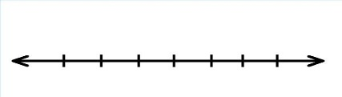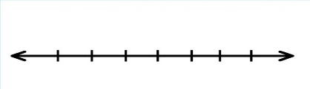

7.  < -6 8. 3 - x > -5 9. 0.75y ≥ -1.50

