AR Remediation Plan – Patterns, Relations, and Functions

Relations, Functions, Tables, Graphs, and Ordered Pairs

STRAND: Patterns, Functions and Algebra

STRAND CONCEPT: Patterns, Relations, and Functions

SOL: 8.15a

Remediation Plan Summary

Students determine if a relation is a function given a set of ordered pairs, a table or a graph.

Common Errors and Misconceptions
- Students may confuse the x-coordinate when determining if a relation is a function.
- Students confuse horizontal and vertical direction when applying the vertical line test.

Materials
- How Does a Snack Machine Work?
- What is a Function? activity sheet
- Function or Not? handout
- Exit Ticket

Introductory Activity
Display “How Does a Snack Machine Work?” for the class. Ask students to jot down a few ideas on a piece of paper. Have students share their ideas with a partner and then have a class discussion. Some ideas may include: you put in money, push a button to select the snack, the snack drops down, your reach in and get your snack, etc.
How would you feel if you selected a Snickers candy bar and got a Payday? Or if you and your friends all selected different snacks and everyone got Doritos? What if you bought a Snickers bar today and got a Snickers and then tomorrow bought a Snickers and got Bugles?
Is this machine functioning correctly? Allow for discussion to each of these questions. What would happen if the machine was functioning correctly?

Plan for Instruction
- Explain to students that today they will be learning about relations and functions. Explain that all snack machines would be examples of relations. However, only some snack machines are functions. Using the scenario from the introductory activity, have the class define what they think a function is. The idea is to introduce the idea of a function where each input (or snack selected) has one and one output (it doesn’t have to be the correct snack but the same snack each time). Use the following definitions:
A relation is any set of ordered pairs. For each first member, there may be many second members.

A function is a relation between a set of inputs, called the domain, and a set of outputs, called the range, with the property that each input is related to exactly one output.
- Distribute the “What is a Function?” activity sheet. Work through the first three examples as a group and discuss what makes a relation a function. Allow students to work in a group to finish the additional practice. Discuss answers and explanations as a class.
- Functions can be displayed in many ways. For this lesson, the focus is on a table, a graph, or a set of ordered pairs. Display examples of each type for students. Using problems #6-9 from the “More Practice” problems above, write the relations shown in each table as a set of ordered pairs.
- Using problems #6-9 from the “More Practice” problems above, create graphs as a class for each of the relations. Using their knowledge of which relations are functions, ask students what strategy they could use when looking at a graph to determine if a graph represents a function or not. If no one initiates a conversation about the vertical line test, introduce it and show students how to apply the vertical line test to determine if a graph is a function or not.
- Distribute copies of the Function or Not? Handout to students. Encourage them to work on their own first and then compare their answers and explanations with a partner. After the class is done, select pairs to share their answers and explanations.

Pulling It All Together (Reflection)
Exit Ticket: Distribute the exit ticket to the students to complete. Use the data from the completed activity to review any misconceptions the next day.

Note: The following pages are intended for classroom use for students as a visual aid to learning.

Virginia Department of Education 2018

How does a snack machine work? 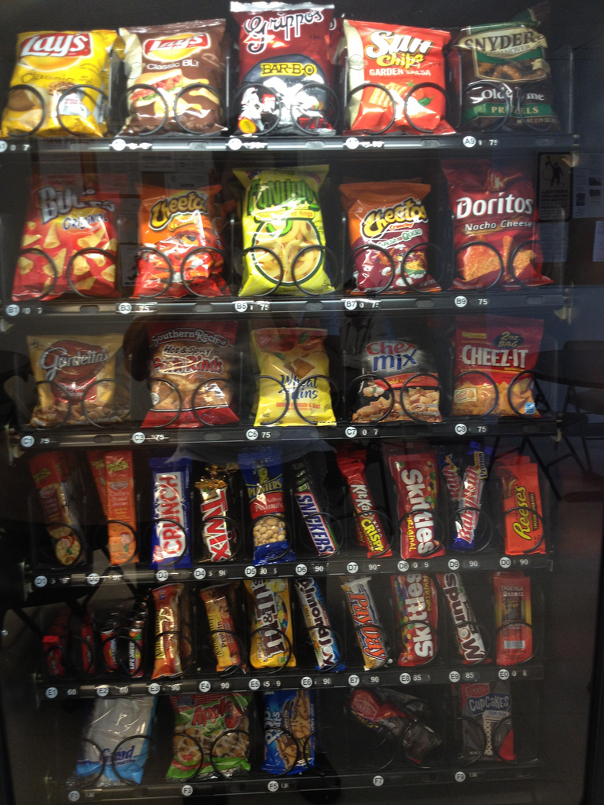

What is a Function?
- Is this machine operating correctly? _________

Selected | Doritos | Cheetos | Snickers | Reeses
Vended | Doritos | Cheetos | Snickers | Reese’s

Is this a function? _________ Explain your answer.

- Is this machine operating correctly? _________

Selected | Doritos | Cheetos | Snickers | Reese’s
Vended | Snickers | Snickers | Snickers | Snickers

Is this a function? _________ Explain your answer.

- Is this machine operating correctly? _________

Selected | Doritos | Reese’s | Doritos | Reese’s
Vended | Cheetos | Snickers | Doritos | Reese’s

Is this a function? _________ Explain your answer.

More Practice:

Is this a function? _________ Explain your answer.

red | blue | green | pink | yellow
d | e | n | k | w

Is this a function? _________ Explain your answer.

red | purple | green | pink | brown
2 | 4 | 3 | 3 | 4

- Is this a function? _________ Explain your answer.

x | 1 | 2 | 3 | 4
y | 5 | 6 | 7 | 8

- Is this a function? _________ Explain your answer.

x | -1 | 0 | 3 | 7
y | 6 | 6 | 6 | 6

- Is this a function? _________ Explain your answer.

x | -5 | -2 | 0 | -5
y | 4 | 1 | -2 | 4

- Is this a function? _________ Explain your answer.

x | 1 | 4 | -2 | 1
y | 3 | 5 | 1 | -2

In your own words, explain what a function is.

______________________________________________________________________________

______________________________________________________________________________

______________________________________________________________________________

______________________________________________________________________________

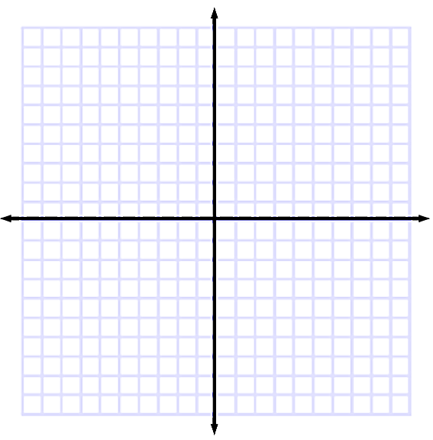

Function or Not?
Determine if the following representations or functions or not? Explain your reasoning.
x y  -1 3  0 3  1 3  2 3  Function or Not a Function  Explanation: | x y  1 2  1 3  1 4  1 5  Function or Not a Function  Explanation:
x y  2 6  3 6  4 5  5 4  Function or Not a Function  Explanation: | { (-4, 1), (1, 1), (-5, 1), (6, 1) }  Function or Not a Function  Explanation:
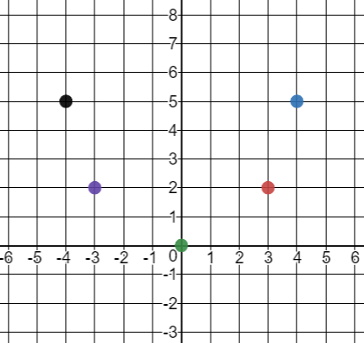  Function or Not a Function  Explanation: | x Y  1 6  2 5  3 4  1 3  Function or Not a Function  Explanation:
{ (0, 4), (-4, -4), (2, -3), (4, 0) }  Function or Not a Function  Explanation: | { (3, -2), (1, 0), (-2, 4), (3, 1) }  Function or Not a Function  Explanation:
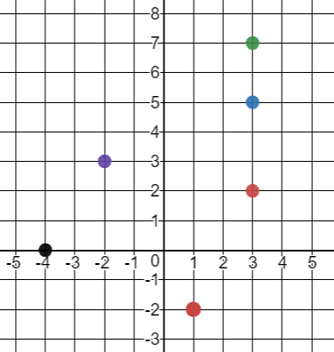  Function or Not a Function  Explanation: | 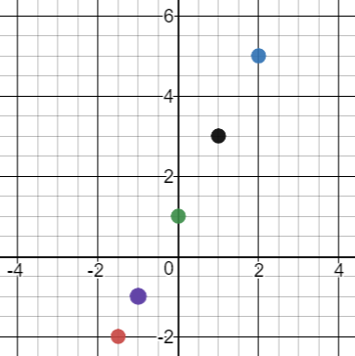  Function or Not a Function  Explanation:
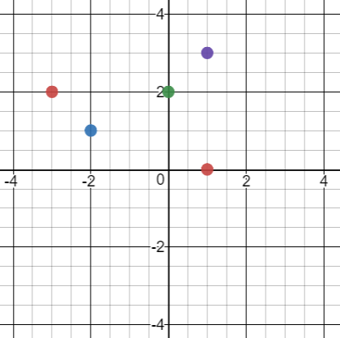  Function or Not a Function  Explanation: | x y  -1 2  0 4  1 6  2 8  Function or Not a Function  Explanation:

Exit Ticket:
Create a set of ordered pairs that represents a function.

Create a graph of a set of ordered pairs that does not represent a function.

