# AR Remediation Plan – Patterns, Relations, and Functions

### Relations, Functions, Domain and Range

### STRAND: Patterns, Functions and Algebra

### STRAND CONCEPT: Patterns, Relations, and Functions

### SOL: 8.15b

#### Remediation Plan Summary

#### Students identify the domain and range of the function.

#### Common Errors and Misconceptions

* Students incorrectly label the x-coordinates as the range and the y-coordinates as the domain.
* If a number repeated in the input or output of the relation, students may incorrectly repeat the number in the domain or range.

#### Materials

* Domain & Range handout
* Exit Ticket

#### Introductory Activity

Play “Guess My Rule”. Display an input/output table for students. Using the function  ask the students to give you a number. Applying the rule, determine the output. Write the student’s number in the input column and your response in the output column. Continue asking for numbers from students until someone guesses the rule. Make up another rule,  , create a second table, and play again. If a student would like to make up a rule, allow them to write it down, give it to you, create a table, and play the game.

#### Plan for Instruction

* Before beginning the lesson, review relation and function. Use the following definitions:  
   -A relation is any set of ordered pairs. For each first member, there may be many second members.

# -A function is a relation between a set of inputs, called the domain, and a set of outputs, called the range, with the property that each input is related to exactly one output.

* Refer to the introductory activity and ask them how the function worked. Look at the tables from the introductory activity and explain that the input (x-value) is the number you put into the rule and the output (y-value) is the solution for the input.
* Display the following information for students:  
   x-coordinate y-coordinate  
   input output  
   domain range  
  *Based upon what we have discussed today, what do you think the word domain means?  
  Based upon what we have discussed today, what do you think the word range means?  
  How are the domain and range different? (***The domain of a function is the set of all input values. The range of a function is the set of all output values**.)
* Explain to students that numbers do not repeat and are organized in numerical order. Look at this example.    
   Domain:  Range:    
  Using the tables from the introductory activity, write the domain and range for each “Guess My Rule” function.
* Distribute the “Domain & Range” handout to students. Allow students to work with a partner to identify the domain and range for tables, graphs, and sets of ordered pairs. Assist students as necessary. Once the students are done, discuss the answers and any misconceptions as a class.

#### Pulling It All Together (Reflection)

Exit Ticket: Distribute the exit ticket to the students to complete. Use the data from the completed activity to review any misconceptions the next day.

**Note: The following pages are intended for classroom use for students as a visual aid to learning.**

Virginia Department of Education 2018

Domain & Range

## For each relation below, identify the domain and range.

**1)**

|  |  |  |  |  |
| --- | --- | --- | --- | --- |
| ***x*** | 1 | 2 | 3 | 4 |
| ***y*** | 5 | 6 | 7 | 8 |

## Domain: Range:

**2)**

|  |  |  |  |  |
| --- | --- | --- | --- | --- |
| ***x*** | -5 | -2 | 0 | -5 |
| ***y*** | 4 | 1 | -2 | 4 |

Domain: Range:

**3) **

Domain: Range:

**4) **

Domain: Range:

**5)**

|  |  |  |  |  |
| --- | --- | --- | --- | --- |
| ***x*** | -1 | 0 | 3 | 7 |
| ***y*** | 6 | 6 | 6 | 6 |

Domain: Range:

**6)**

|  |  |  |  |  |
| --- | --- | --- | --- | --- |
| ***x*** | 1 | 4 | -2 | 1 |
| ***y*** | 3 | 5 | 1 | -2 |

Domain: Range:

**7) **

Domain: Range:

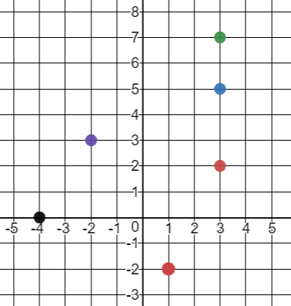

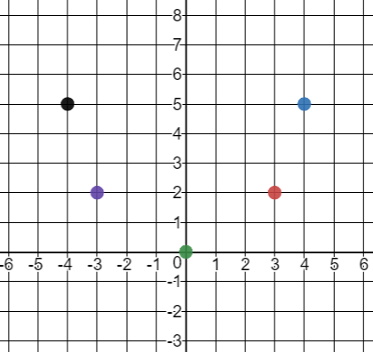**8) 9)**

Domain: Domain:

Range: Range:

Exit Ticket:

Which one doesn’t belong? 

|  |  |  |  |  |  |  |  |  |  |  |  |
| --- | --- | --- | --- | --- | --- | --- | --- | --- | --- | --- | --- |
| Find the outputs of the function represented by the set of ordered pairs. | Find the range of the function represented below:   |  |  |  |  |  | | --- | --- | --- | --- | --- | | ***x*** | 1 | 3 | 5 | 8 | | ***y*** | 2 | 5 | 7 | 11 | |
| Find the domain of the function represented by the set of ordered pairs. | Find the y-values of the function represented by the set of ordered  pairs. |

Circle the one statement that is different from the other three. Explain why it is different.

**Find the error:**

What error did the student make?

|  |  |
| --- | --- |
|  | **Domain**: {-3, -1, 1, 3, 5}  **Range**: {-2, -1, 0, 1, 2} |

Correct the error in the space below.