AR Remediation Plan – Proportional and Additive Relationships; Slope; Linear Functions

Proportional Relationships

STRAND: Patterns, Functions and Algebra

STRAND CONCEPT: Proportional and Additive Relationships; Slope; Linear Functions

SOL: 6.12c,d

Remediation Plan Summary
Students will determine whether a proportional relationship exists between two quantities; and will make connections between and among representations of proportional relationships between two quantities using verbal descriptions, ratio tables, and graphs.

Common Errors and Misconceptions
Students may have difficulty understanding the meaning of proportional relationships. Students sometimes confuse multiplication and division when determining the constant of proportionality.

Materials
- Linking cubes
- Graph paper
- Comparing Proportional vs. Non-proportional Relationships activity sheet (attached)

Introductory Activity
- Discuss the following questions with students to get them thinking about proportional reasoning:
  - What is a ratio?
  - What is a unit rate?
  - How are equivalent ratios created? Explain your reasoning and provide an example.

Plan for Instruction

- Use the Comparing Proportional vs. Non-proportional Relationships activity sheet to compare proportional relationships (multiplicative vs. additive). This activity is used as a means to:
  - Discuss the differences between multiplicative relationships and additive relationships.
  - Determine the characteristics of multiplicative relationships and additive relationships.
  - Determine connections between and among representations of proportional relationships.
  - Explore linear graphs and proportional relationships, both of which are tools to have students further their understanding of what proportionality is (and is not), as well as increasing their ability to make predictions and comparisons using proportional reasoning.
- While facilitating and modeling the discussion, take the time for partners or small groups to engage in student-student talk regarding each question. Discuss how the linking cubes can be used to represent the additive nature of the ratios within a non-proportional relationship, and that additive relationships are a concept discussed in grade 7. Here are some examples of linking cube models:
Mark’s earnings: Tanya’s earnings:
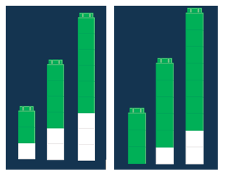

Pulling It All Together (Reflection)
After completing the Comparing Proportional vs. Non-proportional Relationships activity sheet, ask students to create two graphs: one that displays a proportional relationship and another that displays a non-proportional relationship.

Note: The following pages are intended for classroom use for students as a visual aid to learning.

Virginia Department of Education 2018
Comparing Proportional vs. Non-proportional Relationships
Mark wants to start saving money. He has no money in his bank account. He will save $2 per week. Tanya already has saved $3 in her bank account. She will also save $2 per week. The graphs below represent the amount of money each will save per week.
Mark’s Earnings Tanya’s Earnings
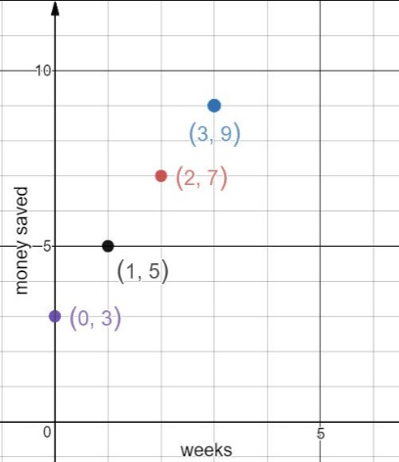
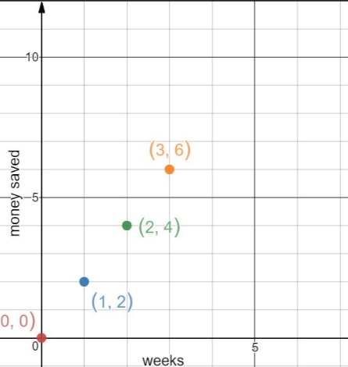

- Use the points on the graph to fill in the ratio tables.
Mark Tanya
Week | Money Saved
Week | Money Saved

- Use linking cubes and draw a picture to show the ratio pairs (money saved per week) for both Mark and Tanya.

- Explain the relationship between money saved and number of weeks on week zero for Mark and Tanya.

- Select two of the non-zero $\frac{Money Saved}{Week}$ ratios within Mark’s table and within Tanya’s table to determine which situation is proportional.

- What makes a ratio table or graph appear to be proportional or non-proportional? Explain your reasoning.

Which graph shows a proportional relationship? Explain your thinking.

What is the unit rate of the proportion? How does your linking cubes model show this?
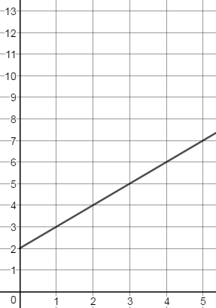
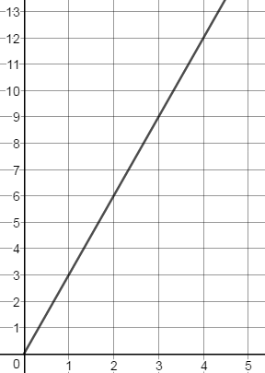
Graph A Graph B

X
X

- Create a ratio table for Graph A and Graph B.

- Which graph/ratio table above represents a proportional relationship? How is it similar to Mark’s or Tanya’s graph/ratio table?

- Which graph/ratio table above represents a non-proportional relationship? How is it similar to either Mark’s or Tanya’s graph/ratio table?

- Explain how you would determine whether a graph/ratio table represents a proportional or non-proportional relationship.

- Create a scenario for Graph A that describes the relationship occurring in the graph.

- Create a scenario for Graph B that describes the relationship occurring in the graph.

