AR Remediation Plan – Equality/Solving Equations

Solving One-Step Equations with an Equation Balance Mat

STRAND: Patterns, Functions and Algebra

STRAND CONCEPT: Equality/Solving Equations

SOL 6.13

Remediation Plan Summary

Students represent and solve one-step equations, using an equation balance mat and counters.

Common Errors and Misconceptions
Some students confuse the letters used to represent the variables when there is more than 1 representation used.

Materials
- Balance scales
- 20 pennies
- “Equation Balance Mat” worksheets
- Red and blue counters

Introductory Activity
Place 10 pennies on one side of a balance scale and 5 pennies on the other side. Ask if the scale is balanced and why or why not. Students should answer “no” because one side has more pennies and is therefore heavier than the other side. Ask what could be done to make this scale balanced. (Put 5 more pennies on the side that is lighter.) Ask students to explain what they know about the weight of two objects when the scale is balanced. (They have the same weight.)

Plan for Instruction
- Distribute an “Equation Balance Mat” worksheet and counters (red and blue) to each student.
- Tell students that each red counter has a value of 1 unit. Explain that students are going to use what they know about the red counters and about balance and equality to determine the value of the blue counter.
- Have students place 1 blue counter and 1 red counter on the left side of the balance shown on their mat and 7 red counters on the right side, as shown:

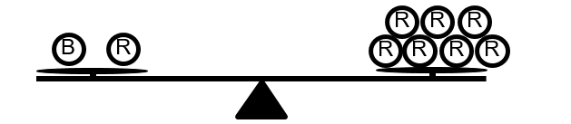

- Ask students what they can see about the value of the red and blue counters on their mats. (The scale is balanced, so the counters on either side must have an equal value.)
- Ask for suggestions on how to write an equation to represent what is shown on the balance scale. (The scale is balanced, which indicates that what is on the left side is equal to what is on the right side. Write an equal sign. On the left side, use a variable, b, to represent the blue counter since you do not know its value. The red counter on the left side has a value of 1, and this can be recorded as “+ 1” after the b. The 7 red counters on the right side have a value of 1 each, and these can be represented by the number 7 on the right side of the equal sign. So the equation is: b + 1 = 7.
- Discuss the meaning of the vocabulary words equation, variable, and term.
- Encourage the students to develop a strategy for finding the value of the blue counters. If the students have difficulty, ask them what will happen when you take the one red counter off of the left side of the balance. (The scale will be out of balance.) Ask what they would need to remove from the right side in order to maintain the balance. (One red counter)

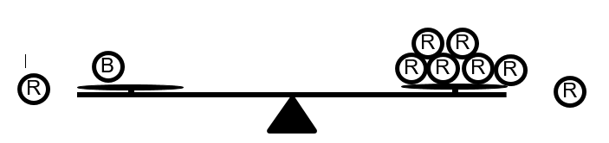

- Ask students to represent changes in the equation. (Subtract 1 from each side of the equation: b + 1 − 1 = 7 − 1.) This leaves one blue counter balanced with 6 red counters. Therefore, one blue is equal to 6 red, or b = 6.
- Have the students use the counters and the equation balance mat to solve another equation, x + 3 = 8, using the process above. Students should set up their balance scale to represent the equation as follows:

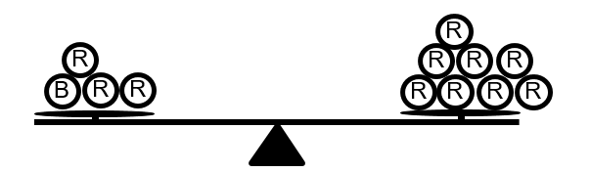

- Provide more examples as needed.

Pulling It All Together (Reflection)
Have students complete the “Reflection” worksheet.

Note: The following pages are intended for classroom use for students as a visual aid to learning.

Virginia Department of Education 2018
Equation Balance Mat

Name:

Reflection

The weight of each gray triangle below is 1 unit. The weight of the rectangle is unknown. Write an equation to represent the weight on the balance scale. Use a variable to represent the weight of the rectangle.

Equation: _______________________

Identify the variable(s) and term(s) in your equation:

variable(s): ________________

term(s): ________________

What is the value of the variable representing the weight of the rectangle? _______

Explain how you found your answer:

