AR Remediation Plan – Proportional and Additive Relationships; Slope; Linear Functions

Y-Intercept and Additive Relationships

STRAND: Patterns, Functions, and Algebra

STRAND CONCEPT: Proportional and Additive Relationships; Slope; Linear Functions

SOL 7.10e

Remediation Plan Summary
Students determine the y-intercept in an additive relationship between two quantities and write an equation in y = x + b form. Students graph a line representing an additive relationship between two quantities given the y-intercepts and an ordered pair or given the equation in y = x + b form.

Common Errors and Misconceptions
- Students may confuse the x- and y-intercepts
- Students may confuse additive and proportional relationships.

Materials
- Warm Up activity sheet
- Activity pages

Introductory Activity
Have students complete the “Warm-up” activity to practice plotting points in a coordinate plane and identifying the pattern of the values for x and y that lie on the x-axis and y-axis.

Plan for Instruction
- Present the following practical situation to students:

John wants to hang a tire swing in his backyard. He is trying to determine from which branch he would like to hang the swing. He has decided that he needs enough rope to reach the branch from the correct height for the tire to hang plus an additional 6 feet to tie the rope around the tree branch and tire.

The following table shows the height, x, in feet from the tire to the branch for various tree branches that might work in his yard. He needs to determine the total length of rope, y, in feet needed for each height before he makes a decision of where to hang the tire swing.
x | y
5
7.5
11

x

Ask students how they determined the values for y in the table. Have them determine what would be an equation that could model this situation. Discuss with students how they determined that y = x + 6 models this situation. Use the coordinate grid below to create a graph of this situation. Discuss what it means when x is zero in this situation. Ask students if the points in this graph should be connected by a straight line. Be sure to point out that only the first quadrant of the graph is used based on the context.
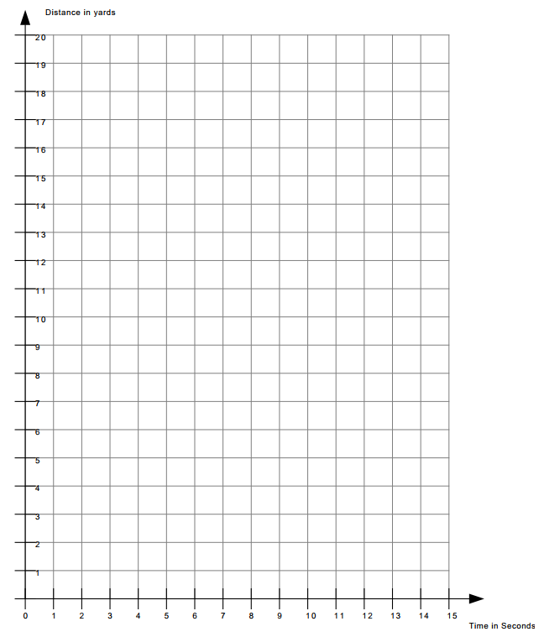
x
y

- Students will create tables using the situations that are given on the Activity Work 1 page and make graphs to represent the information.
- Students should create an equation in the form y = x + b that represents the information from the table and the graph. Students should understand that b represents the y-intercept. Reinforce with students that the coordinate point for the y-intercept should have an x-value of zero. For example, a y-intercept of 3 would be (0, 3). Note that the parameters of SOL 7.10 define the slope (ratio of y to x) is equal to 1.
- Have the students complete the Activity pages.

Pulling It All Together (Reflection)

Exit Ticket: Graph the line y = x – 2. Create a table of values for this relationship. Determine a practical situation that could be modeled by the equation.

Note: The following pages are intended for classroom use for students as a visual aid to learning.

Virginia Department of Education 2018

Name:

Warm-up
Graph the points represented by the ordered pairs shown in the table.
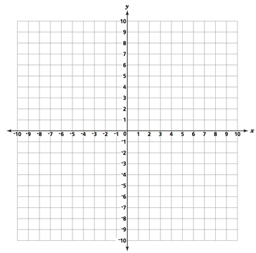

x | y
0 | -3
0 | -5
0 | 0
0 | 9
1 | 0
4 | 0
7 | 0
-2 | 2
3 | 3

List the coordinates of the ordered pairs that lie on the x-axis:

List the coordinates of the ordered pairs that lie on the y-axis:

What do you notice?
- Suzanne’s cousin gives her a 9-yard head start before they start racing. If Suzanne can run 1 yard per second, make a table of values, graph, and an equation that represents total distance from the starting point that Suzanne has run based on the time that has elapsed.
Time | Distance

y = x + ____

Activity Work 2
- A trampoline park charges Ron $12.00 to enter the building and then $1.00 for each hour he plays. Make a table of values, graph, and an equation that represents the total cost Ron will pay based on the number of hours he spends at the park.
y = x + ____
Hours | Cost
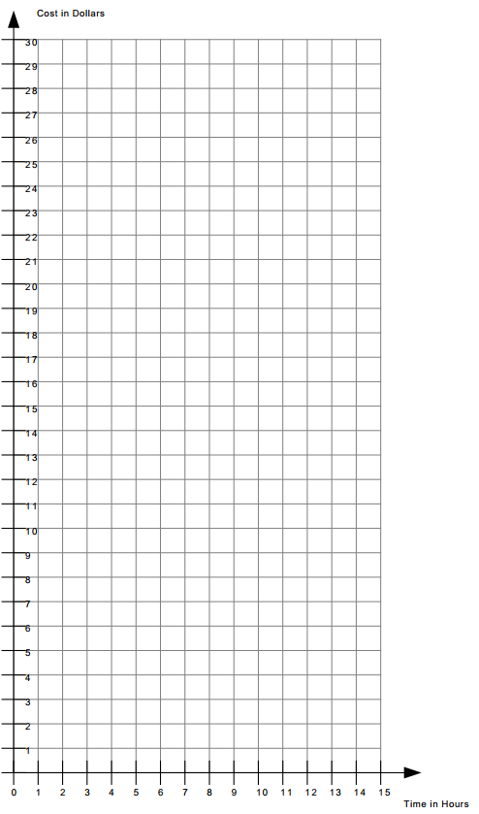

Activity Work 3
- A new pizzeria charges $4.00 for a personal size cheese pizza. They then charge you $1.00 for each topping you choose to add to the cup of ice cream. Make a table of values, graph, and an equation that represents the total cost of the pizza based on each additional topping.
y = x + ____
Topping | Cost
