AR Remediation Plan – Rational Numbers Compare and Order

# Zero, Half, Whole?

## STRAND: Number and Number Sense

## STRAND CONCEPT: Rational Numbers Compare and Order

## SOL 6.2b, 7.1c, 8.1

### Remediation Plan Summary

Students use a number line and table to build an understanding of how to order rational numbers.

### Common Misconceptions

* Some students believe that decimal numbers to the thousandths are greater than one whole.
* Some students struggle placing fractions, decimal, and percents on a number line. They see the decimal and plot the value on the number line as if it was a decimal and not a percent.

### Materials

White boards, white board markers, number line, *Close To…* Introductory handout, *Where do I belong handout*, rational number cards, *Zero, Half or Whole Wrap-up*

### Introductory Activity

Have students complete the Close To… Introductory handout. Once students finish the questions, have a discussion on the numbers students associated with 0, , and 1.

### Plan for Instruction

1. Hand each student a white board marker and number line (either laminated or in a plastic sleeve).
2. On the board, write and have students plot it on the number line.
   1. Have student hold up their number lines for the class to see.
   2. Ask, “Did everyone plot it in the same place?”
   3. Have a class discussion on the correct location for.
3. On the board, write 0.532 and have them plot this point on their line.
   1. Again have them to hold up their board for all to see. This one will be a little more challenging.
   2. Have students explain their number line.
   3. Use money to help students who do not understand the value of 0.532.
      * 1. To Give students a way to connect decimals to real life, relate to place value by asking how many dimes (tenths) would there be? Pennies (hundredth)?
        2. What does the 2 represent (2 tenths of a penny or thousandths)?
4. On the board, write 87%, 0.3% and 108% one at a time and have them plot this number on their line and follow the same questioning as before.
5. To give students a way to connect percents to real life, relate them to assignment grades.
6. Group students and hand each group a Chart and a baggie of rational number cards.
7. Have students read the chart and explain to their group what they think they will do with the cards.
8. Discuss as a class the expectation of sorting/placing cards.

### Pulling It All Together (Reflection).

Give students the four question handout and have them complete it individually. Encourage them to use the strategies from the number line and benchmarking chart. (Create several answer keys with numbers plotted on a number line next to the answers. Have students check their work and look at wrong answers.

**Note: The following pages are intended for classroom use for students as a visual aid to learning.**

#### Close To…

1. Write 5 different numbers that would be close to .
2. Write 5 different numbers that would be close to one whole.
3. Write 5 different numbers that would be close to zero.

#### Close To…

1. Write 5 different numbers that would be close to.
2. Write 5 different numbers that would be close to one whole.
3. Write 5 different numbers that would be close to zero.

#### Where do I Belong???

Place the rational number cards in the column that best fit the value.

| Close to 0 | Close to | Close to 1 |
| --- | --- | --- |
|  |  |  |

#### Rational Number Cards

|  |  |  |  |  |  |  |  |  |  |
| --- | --- | --- | --- | --- | --- | --- | --- | --- | --- |
| 0.3% | 0.6% | 0.008 |  | 0.141 | 19% | 0.2 |  | 27% | 0.33 |
| 0.519 |  |  |  |  | 0.56 | 0.045 | 47% | 52% | 49.5% |
| 0.82 |  |  | 65% | 0.899 |  | 0.68 | 90% |  | 109% |

#### Rational Number Cards

|  |  |  |  |  |  |  |  |  |  |
| --- | --- | --- | --- | --- | --- | --- | --- | --- | --- |
| 0.3% | 0.6% | 0.008 |  | 0.141 | 19% | 0.2 |  | 27% | 0.33 |
| 0.519 |  |  |  |  | 0.56 | 0.045 | 47% | 52% | 49.5% |
| 0.82 |  |  | 65% | 0.899 |  | 0.68 | 90% |  | 109% |

#### Number Line

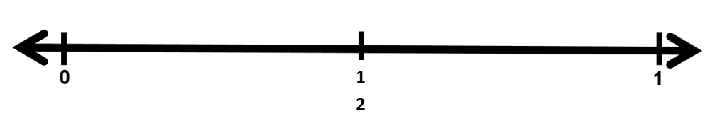

#### Number Line



#### Zero, Half or Whole Wrap-up

Use your number line. Put the following numbers in order from least to greatest.

1. , 48%, 0.11, 109%

Use your number line. Arrange the following numbers in descending order.

1. 50%, , 0.3, 0.87

Use your number line. Compare the following numbers using inequality symbols.

1. 42% ___ 
2. 0.67% ___ 0.37

#### Zero, Half or Whole Wrap-up

Use your number line. Put the following numbers in order from least to greatest.

1. , 48%, 0.11, 109%

Use your number line. Arrange the following numbers in descending order.

1. 50%, , 0.3, 0.87

Use your number line. Compare the following numbers using inequality symbols.

1. 42% ___ 