AR Remediation Plan – Rational Numbers- Compare and Order

Order Scientific Notation

STRAND: Number and Number Sense

STRAND CONCEPT: Rational Numbers - Compare and Order

SOL 7.1b

Remediation Plan Summary
This lesson is meant to be introduced after students are comfortable investigating scientific notation. Students will be comparing and ordering numbers greater than zero written in scientific notation.

Common Errors and Misconceptions
- Students have difficulty comparing scientific notation because they don’t take the exponents into account but only look at the numbers and compare them.
- Students have difficulty comparing scientific notation because they don’t take the decimal number into account but only look at the powers of ten and compare them.
- Students may confuse the words ascending and descending when ordering numbers.
- Students sometime don’t check the reasonableness of their answer. For example if the scientific notation form has a power of ten with a negative exponent, they don’t check to make sure that their answer is a decimal between 0 and 1.
- Students may not understand that if the first factor is between 1 and 10, they just need to compare of the power of 10.
- They may also not understand that if they are comparing two numbers with the same power of ten, they just have to compare the first factor that is between 1 and 10.

Materials
- 0 to 9 spinner (one per student)
- Paper clip and pencil for a spinner
- Dice – 3 dice for each student (The dice can be 1-6 or 1-9 die)
- White boards or blank paper
- Recording sheet
- Exit Ticket

Introductory Activity
- Have students order the following whole numbers in ascending order.
730,000 63,897 15,000,000 9,999
Discuss the steps to order numbers. Ask them why the number with a 9 in the thousands place is smaller than the number in the 1 in the ten millions place. Have them change all the numbers into scientific notation. Did the number change in value? Is the number still worth the same amount just written in a different style?

Plan for Instruction
- Have the students work together in groups of 3 or 4. They will be generating numbers with dice and the digit spinner.
- Each student will roll 3 die. They will make a number between 1 and 9.99. Next, they will spin the digit spinner and that number will be the exponent for their scientific notation. For example- roll a 4, 8, 3, and spin a 7. You could make 8.43 x 10⁷ or 3.84 x 10⁷.
- Have all students in the group create their own number. Students will need to write down the numbers the group creates on a whiteboard, a piece of paper or on the back of the recording sheet.
- After the group has created 12-16 numbers in scientific notation, have the students work together to compare their numbers. Groups will write them in ascending and descending order filling in the recording sheet.

Pulling It All Together (Reflection)
Have the students complete the exit ticket.

Note: The following pages are intended for classroom use for students as a visual aid to learning.

0 to 9 Spinner
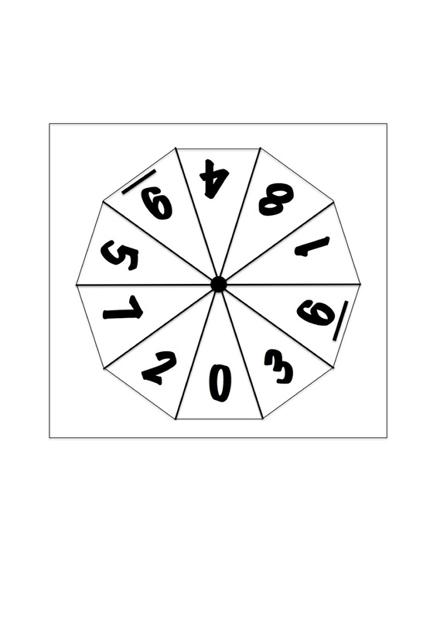

Names _______________________________________________________________________

Recording Sheet

Fill in the chart below recording the scientific notation in ascending order.

Fill in the chart below recording the scientific notation in descending order.

Name _______________________
Exit Ticket

- When you compare numbers written in scientific notation, why do you look at the exponents first?

- When you have two or more numbers with the same exponent, how do you know which number is the biggest and which is the smallest?

- Write the following numbers in ascending order.

8.06 x 10³ 1.9 x 10⁹ 2.02 x 10⁴

- Write the following numbers in descending order.

5.61 x 10⁵ 3.99 x 10¹ 7.16 x 10⁰

