AR Remediation Plan – Circles and Polygons-Classify and Measure

### Quadrilaterals

### STRAND: Measurement and Geometry

### STRAND CONCEPT: Circles and Polygons-Classify and Measure

### SOL 4.12, 7.6a

#### Remediation Plan Summary

Students analyze properties of quadrilaterals s to develop definitions of *square, rectangle, parallelogram, rhombus,* and *trapezoid,* using geoboards.

#### Common Errors and Misconceptions

* Students may confuse the names of the different types of quadrilaterals.
* Students may not understand that a square is also a rectangle and a rhombus.
* Students may assume that all rectangles are squares or that all rhombi are squares.

#### Materials

* Quadrilateral Concept Card warm up
* Geoboards and an overhead geoboard
* Geoboard dot paper
* Quadrilateral Table recording sheet
* Quadrilateral Study Guide worksheets

#### Introductory Activity

Give each student a “Quadrilateral Concept Card.” Have students follow along as you read and discuss each of the statements. Based on the information given on the concept card and the class discussion, have students draw their own examples of a polygon, non-polygon, quadrilateral, and non-quadrilateral. Have students also write their own definitions, based on their understanding of the words in context. When students are finished, have them share their card with a partner. Bring the class together, and go over the students’ responses. Read the definitions of *polygon* and *quadrilateral* to the class, and allow students to change their definitions to make them more accurate, as necessary.

#### Plan for Instruction

1. Display a geoboard for the class to see. On this geoboard, show several four-sided figures. Ask students to identify what they all have in common. (The number of sides) Instruct students that all four-sided figures are called *quadrilaterals*. Focus on the prefix *quad,* and brainstorm other words to help with meaning.
2. Hand out geoboards and rubber bands, and review class rules about working with these materials. Allow the students to explore shapes with the geoboards for a few minutes. If you don’t have access to geoboards, hand out copies of the geoboard dot paper to students.
3. Have students make a shape on their geoboard that is a quadrilateral with both pairs of opposite sides parallel and equal in length. Make this shape on the overhead geoboard. Discuss the properties of this figure: it has four sides, both pairs of opposite sides are parallel, opposite sides are congruent, opposite angles are congruent, a diagonal divides the shape into two congruent triangles. Tell the students that the name for this figure is **parallelogram**. Hand out dot paper, and have students copy their figure (or yours, if theirs was incorrect) on the dot paper and label it “parallelogram.”
4. Have students make a **rectangle** on their geoboard. When they finish, make one on the overhead geoboard. Discuss the properties of a rectangle: it is a parallelogram with four right angles. Have students copy their rectangle on dot paper and label it “rectangle.”
5. Ask for a volunteer to make a **square** on the overhead geoboard. Discuss the properties of a square: it has all of the properties of a parallelogram, and it is also a rectangle with four congruent sides. Have students copy the square on dot paper and label it “square.”
6. Ask students to make a **rhombus** on their geoboard, and replicate it on the overhead. Guide students to discover that a rhombus has the properties of a parallelogram, which it has four congruent sides, and that opposite angles of a rhombus are congruent. Have the students label their figure “rhombus.”
7. Ask students to make a four-sided shape on their geoboard with only one pair of opposite sides parallel. Ask whether anyone knows the name of this figure. Tell students that it is a **trapezoid**—a four-sided figure with exactly one pair of parallel sides.
8. Have individual students come to the overhead geoboard and create different types of quadrilaterals—rectangle, square, parallelogram, rhombus, and trapezoid—to review the properties and definitions of these quadrilaterals.
9. Have pairs of students complete the “Quadrilateral Study Guide.” Provide assistance as needed.

#### Pulling It All Together (Reflection)

Option 1:

Exit Ticket: Compare and contrast a rhombus and a rectangle. How are these shapes similar and how are they different?

Option 2:

Have students complete the “Quadrilateral Table” worksheet. (This activity can also be done as a warm up the next day.)

**Note: The following pages are intended for classroom use for students as a visual aid to learning.**

# Virginia Department of Education 2018

### Name:

Quadrilateral Concept Card

**Polygons**

These figures are polygons:

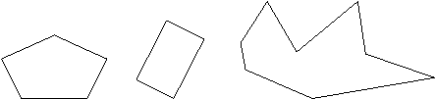

These figures are not polygons:

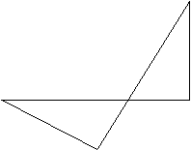

Which of these figures are polygons? (circle your answer)

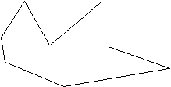

Draw your own example of a polygon.

Draw your own example of a non-polygon.

What is a polygon?

A polygon is

.

**Quadrilaterals**

These figures are quadrilaterals:

These figures are not quadrilaterals:

Which of these figures are quadrilaterals? (circle your answer)

Draw your own example of a quadrilateral.

Draw your own example of a non-quadrilateral.

What is a quadrilateral?

A quadrilateral is

.

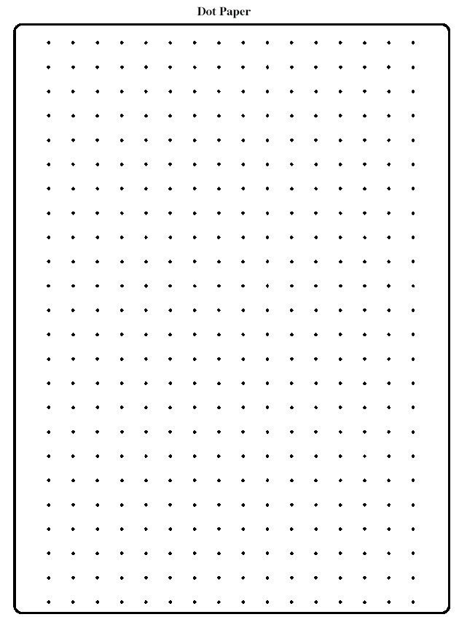Dot Paper

### Name:

Quadrilateral Study Guide

Fill in the blanks, and draw the figures as directed.

1. A \_\_\_\_\_\_\_\_\_\_\_\_\_\_\_\_\_ is a polygon with four sides. Draw several examples of this below.

2. A \_\_\_\_\_\_\_\_\_\_\_\_\_\_\_\_\_ is a quadrilateral in which both pairs of opposite sides are parallel.

3. Properties of a parallelogram include the following:

a. A diagonal divides a parallelogram into two congruent \_\_\_\_\_\_\_\_\_\_\_\_\_\_\_\_\_.

b. The opposite sides of a parallelogram are \_\_\_\_\_\_\_\_\_\_\_\_\_\_\_\_\_.

c. The opposite angles of a parallelogram are \_\_\_\_\_\_\_\_\_\_\_\_\_\_\_\_\_.

For questions 4–8, refer to the drawings on the right.

ED00279_4. A \_\_\_\_\_\_\_\_\_\_\_\_\_\_\_\_\_ is a parallelogram with four right angles. Since a \_\_\_\_\_\_\_\_\_\_\_\_\_\_\_\_\_ is a parallelogram, it has the same properties as those of a parallelogram.

ED00278_

5. A \_\_\_\_\_\_\_\_\_\_\_\_\_\_\_\_\_ is a rectangle with four congruent sides. Since a \_\_\_\_\_\_\_\_\_\_\_\_\_\_\_\_\_ is a rectangle, it has all the properties of a rectangle and of a parallelogram.

ED00282_6. A \_\_\_\_\_\_\_\_\_\_\_\_\_\_\_\_\_ is a parallelogram with four congruent sides. Opposite angles of a \_\_\_\_\_\_\_\_\_\_\_\_\_\_\_\_\_ are congruent. Since a \_\_\_\_\_\_\_\_\_\_\_\_\_\_\_\_\_ is a parallelogram, it has all the properties of a parallelogram.

ED00280_

7. A \_\_\_\_\_\_\_\_\_\_\_\_\_\_\_\_\_ is a quadrilateral with exactly one pair of parallel sides.

### Name:

Quadrilateral Table

Place a check mark in the appropriate boxes to show which figures have which properties. Then answer the questions that follow.

|  |  |  |  |  |  |  |
| --- | --- | --- | --- | --- | --- | --- |
| **PROPERTY**  **OF FIGURE** | **TYPES OF POLYGONS** | | | | | |
| **Quadrilateral** | **Parallelogram** | **Rectangle** | **Rhombus** | **Square** | **Trapezoid** |
| Only one set of parallel sides |  |  |  |  |  |  |
| Two sets of parallel sides |  |  |  |  |  |  |
| Two sides of equal length |  |  |  |  |  |  |
| Four sides of equal length |  |  |  |  |  |  |
| Four angles of equal measure |  |  |  |  |  |  |
| All four angles are right angles |  |  |  |  |  |  |
| It may contain a right angle |  |  |  |  |  |  |

Is a square a rectangle? \_\_\_\_\_ How do you know this?

I have four sides and two sets of equal sides, but not all four of my sides are equal, and I have two sets of parallel sides. What shape(s) can I be? \_\_\_\_\_\_\_\_\_\_\_\_\_\_\_\_\_\_\_\_\_\_\_\_\_\_\_\_\_\_\_\_\_\_\_\_\_\_\_\_\_\_\_\_\_\_\_\_\_\_\_\_\_\_\_\_\_\_\_\_\_\_\_\_\_\_\_\_\_\_\_\_\_\_\_\_\_\_\_\_\_\_\_\_\_\_\_\_\_\_\_\_\_\_\_\_\_\_\_