AR Remediation Plan: Point, Line, Line Segment, Ray, and Angle-Identify, Describe, Classify, and Measure

Estimating Angle Measures

STRAND: Measurement and Geometry

STRAND CONCEPT: Point, Line, Line Segment, Ray, and Angle-Identify, Describe, Classify, and Measure

SOL 5.12

Remediation Plan Summary
Students use a guideline protractor in intervals of 45° to estimate the measure of angles before finding the exact measures.

Common Misconceptions
Students have a difficult time measuring an angle. They do not place the vertex on the center point of the protractor. Once they have lined up a protractor, they are not sure which set of numbers to use when reading the protractor. They do not understand where the zero is and how to read the protractor. They also sometimes don’t understand that a degree is actually of a circle.

Materials
- Teacher Judy clock for demonstration
- Clock face hand out
- Craft sticks
- Wax paper, patty paper, or tracing paper
- Permanent markers
- Protractors
- “Estimating and Measuring Angles” worksheets
- “Reflection” worksheets

Introductory Activity
Give every student a clock face hand out and 2 craft sticks. Have the students make different times using the craft sticks. Ask them to look at the angle that is made by the craft sticks. Begin with 3:00. Let them know this is a right angle. It is 90º. What about 9:00 is that a right angle? Are there any other right angles? Have them make 2:00, what type of angle is that. Go through several different times and angle measures. Discuss that today will be measuring angles using protractor.

Plan for Instruction
- Distribute a piece of wax paper (or tracing paper or patty paper), a protractor, and a permanent marker to each student.
- Have students draw a straight line on the wax paper with their permanent marker. The line should be 5 to 6 inches in length.
- Direct the students to place their protractor so that both ends of the line are on the 0° marks, and have them mark a point at the center mark, the 45° mark, the 90° mark, and the 135° mark.
- Have students connect each point to the center point with a straight line. (See drawing on next page.) This creates a “guideline protractor” marked in intervals of 45°—a great tool for estimating the measurement of angles.
- Direct students to label the guideline protractor with the inside and outside measurements so that it looks like a regular protractor.
- Explain to students how they can use their guideline protractor just like a regular protractor as a tool to estimate angles. Students place the guideline protractor on top of the angle they want to measure, making sure that the center is on the vertex and one ray is on the 0° mark of the protractor. They then estimate the measurement of the angle by seeing between which two measurements the angle lies.
- Distribute copies of the “Estimating and Measuring Angles” worksheet. Have students use their guideline protractor to estimate the measurement of each angle and to record their estimates. Remind students to extend the rays, if needed, and to decide whether the angle is acute or obtuse before measuring.
- After all angle measurement have been estimated, have students use a regular protractor to find the actual measurement of each angle and record these actual measurements.
- Ask the students to compare their estimated measurements to their actual ones. Were they close? Have a discussion about how close an estimate needs to be for it to be useful. In what situations is an estimate useful?

Pulling It All Together (Reflection)
Have students complete the questions on the “Reflection” worksheet.

Note: The following pages are intended for classroom use for students as a visual aid to learning.

Virginia Department of Education 2018

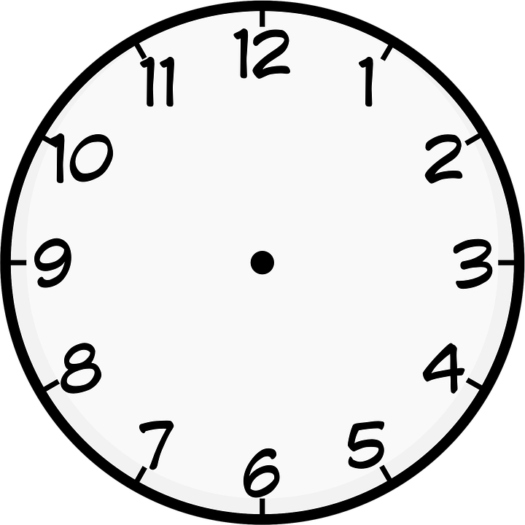
Guideline Protractor

0°
180°
45°
135°
90°
135°
45°
180°
0°

Name: ________________________________

Estimating and Measuring Angles

Use your guideline protractor to estimate the measurement of each angle. Use your regular protractor to get the exact measurement.

1. Estimation: _______________________________
Actual: _______

2. Estimation: _______________________________
Actual: _______

3. Estimation: _______________________________
Actual: _______

4. Estimation: _______________________________
Actual: _______

5. Estimation: _______________________________
Actual: _______

6. Estimation: _______________________________
Actual: _______

Name: ______________________________

Reflection

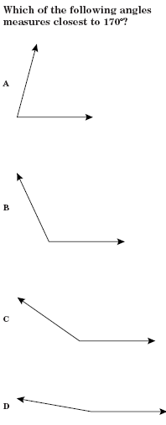
1. To the right is a practice SOL question. Use your guideline protractor only to find the correct answer. Circle your answer.
2. Explain how you used your guideline protractor to find the correct answer.

3. How could you figure out the answer without a protractor or a guideline protractor?

