AR Remediation Plan – Congruence and Similarity

Congruent or Similar?

STRAND: Measurement and Geometry

STRAND CONCEPT: Congruence and Similarity

SOL 6.9, 7.5

Remediation Plan Summary
Students sort a set of triangles into pairs and discover the relationship between figures that are similar or congruent. Students create similar and congruent figures on geoboards.

Common Misconceptions
- Students may incorrectly think that figures are not congruent or similar because they have been rotated or are not shown in the same orientation.

Materials
- Sets of Similar and Congruent Triangle Sorting Pieces
- Geoboards
- Rubber bands
- Applying the Lesson activity
- Similar or Congruent? exit slip

Introductory Activity
Copy the 12 “Similar and Congruent Triangle Sorting Pieces” onto card stock and cut them out, making enough sets of 12 pieces to give a complete set to each pair of students. Alternatively, have each pair of students cut out their own set. After distributing the sets, ask the partners to pair up the triangles that are related in some way, explaining that for each triangle, there is another that is like it in one way or another. Have students write down the triangle pairs they matched and an explanation of why they paired the triangles the way they did.

Plan for Instruction
- Have student partners orally explain how they paired the triangles.
- Talk about the triangles that are the same shape and same size. Give the students the definition of congruent figures. Show example of congruent triangles. Have students explain why the triangles are congruent.
- Talk about the triangles that are the same shape but not the same size. Give the students the definition of similar figures. Show example of similar triangles. Have students explain what makes the pairs similar. What is the difference between congruent and similar figures?
- Pass out geoboards and rubber bands. Have students create similar and congruent figures according to your directions. For example, say, “Show me similar rectangles.” Students should create two rectangles of the same shape but different size. Have students practice making these until they are familiar with the terms similar and congruent.
- Have the students complete the “Applying the Lesson” activity sheet, giving assistance as needed. As students are working, look for common errors or misconceptions to address with the class.

Pulling It All Together (Reflection)
Have students complete the “Similar or Congruent?” exit slip.
Note: The following pages are intended for classroom use for students as a visual aid to learning.

Similar and Congruent Triangle Sorting Pieces

Similar and Congruent Triangle Sorting Pieces
F

I

K

G

B

Similar and Congruent Triangle Sorting Pieces
E

D

L

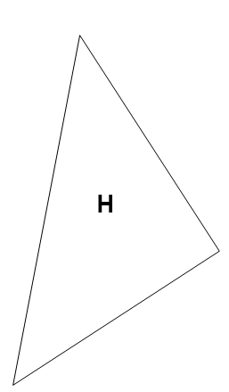
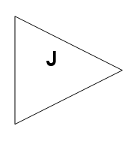
C

A

Name:

Applying the Lesson
In the first box in each row, draw a simple figure. In the second box in that row, draw a figure similar to the original. In the third box, draw a figure congruent to the original figure.

Original Figure Similar Figure Congruent Figure

Name:

Exit Slip: Similar or Congruent?
Label each pair of figures below as similar, congruent, or neither. Then, justify your answer with its mathematical definition.

1. These figures are ____________________ because

2. These figures are ____________________ because

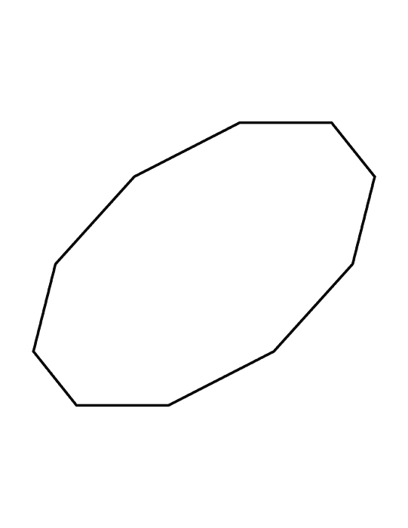

3. These figures are ____________________ because

4. These figures are ____________________ because

5. These figures are ____________________ because

