AR Remediation Plan – Volume and Surface Area

Cones and Square Pyramids

STRAND: Measurement and Geometry

STRAND CONCEPT: Surface Area

SOL 7.4b, 8.6a

Remediation Plan Summary
Students use mathematical reasoning and formulas to compute the surface area of cones and square pyramids.

Common Errors and Misconceptions
Students have a difficult time differentiating between prisms and pyramids. They have difficulty differentiating between area and perimeter and volume and surface area. Students use the units for measurement incorrectly.

Materials
- Square pyramids and cones examples
- Nets of a cone and a square pyramid
- Grid paper
- Rulers
- Copies of the Grade 8 Mathematics Formula Sheet

Introductory Activity
Hold up an example of a cone and a square pyramid ask the students how they are the same and how they are different. Ask the students what shapes make up each solid. Ask the students to try and draw the solid on a piece of grid paper using the shapes that make up the solid. Discuss what they each drew.

Plan for Instruction
- Give each student a copy of the net of a cone and grid paper. Have them cut out each net and trace the net onto the grid paper. Have the students examine their nets, ask them to estimate the surface area that their nets cover on the paper.
- What shape is the base of the cone? How would you find the area of the base of the cone. Discuss the formula for the area of a circle. () Students can use a ruler or the grid paper to determine the radius of the circle.
- Have the students use a ruler to measure the slant of the cone from the vertex to the base. Use the radius of the circle for the base. The formula for the surface area of the top of the cone is . The l represents the slant of the cone.
- Ask students how they can find the total surface area of the cone. If needed, guide them to suggest adding the area of the base and the lateral area of the cone. Show students the formula for surface area of a cone on the formula sheet, and discuss how the formula models the process they just finished. Have students work a new surface-area-of-a-cone problem with different dimensions. Measuring a real object, such as a slush cone or party hat, works well if you add a base.
- Have students do a Think-Pair-Share, asking: “How would you find the total surface area of a square pyramid?”
- Give each student a net of a square pyramid. Model finding the total surface area of the square pyramid while having the students record the areas of the square base and the triangular faces directly on the net. Have students find the total surface area by adding the base area to the lateral area of the pyramid. Have them record the steps of the process in sketches, numbers, and words.
- Shift to the formula SA = $\frac{1}{2}$lp + B, where p equals the perimeter of the square base and B equals the area of the square base. Ask students to explain which part of the formula refers to the total lateral area ($\frac{1}{2}$lp) and which part to the area of the base (B). Link the formula for the area of one triangular face ($\frac{1}{2}$ × length of side of base × slant height) to the sum of the four faces needed in surface area by using the perimeter of the square base as the sum of all four triangular bases.
- Give students two new sets of dimensions for two new situations requiring measurement of square pyramids. Have them record these situations on the “Finding the Surface Area of a Square Pyramid” worksheet.
- Have students work together in pairs to complete the “Finding Surface Area of Solids” worksheet, using their solids as a reference.

Pulling It All Together (Reflection)
Exit card answer the following questions
- To find the surface area of a cone or a square pyramid what do you have to know?

- What do the face and base have to do with finding the surface area?

Note: The following pages are intended for classroom use for students as a visual aid to learning.

Net of a cone
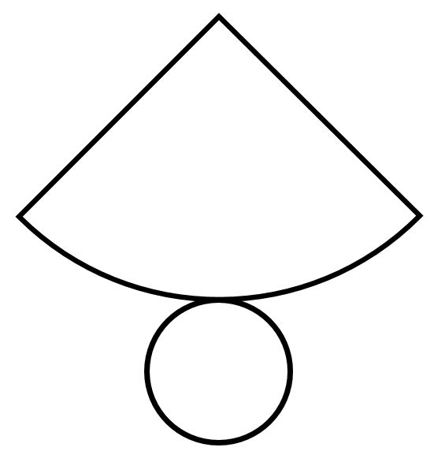

Net of pyramid

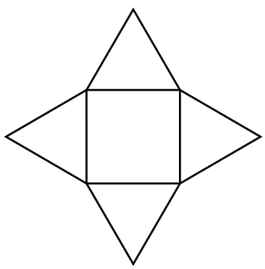

Name:

Finding the Surface Area of a Square Pyramid
Draw a sketch for each word problem below. Label the dimensions from the word problem on the sketch. Write the formula in symbols and in words. Find the surface area in square units by using the formula and then explaining your steps in words.

Taylor is building a paper model of a square-based pyramid for his Egypt project. The square base measures 7 cm x 7 cm. The slant height is 8.5 cm. How much paper does Taylor need?  Sketch:  Formula in symbols:  Formula in words:  Surface area in square units:  Explain your steps in words. | Jake is making a tent in the shape of a square pyramid, using canvas. Each side of the square base is 5 feet long, and the slant height is 7 feet. How much canvas does Jake need for the base and the lateral area of the tent?  Sketch:  Formula in symbols:  Formula in words:  Surface area in square units:  Explain your steps in words.

