AR Remediation Plan – Practical Applications-Rational Number and Proportional Reasoning

Practical Problems – Consumer Applications

STRAND: Computation and Estimation

STRAND CONCEPT: Practical Applications-Rational Number and Proportional Reasoning

SOL 8.4

Remediation Plan Summary
Students will solve practical problems involving consumer applications.

Common Misconceptions
- Students may mix up the whole and the part when trying to write the proportion for the word problem.
- Students will incorrectly set up the proportions by always putting the variable as the numerator in the second ratio or over 100.
- Students may forget to convert a percent to a decimal or fraction before solving the equation.

Materials
- “Scoop-on-Ice-Cream” handout

Introductory Activity
Ask students what their favorite ice cream flavor is and record the responses. As a group, calculate what fraction and/or percentage of students like each flavor. You may want to limit the choices to five flavore or fewer. Ask students if they think these percentages would be the same for other classes or the whole school.

Plan for Instruction
- Give each student a copy of the handout “Scoop-on-Ice-Cream Recording Sheet,” and discuss the information about favorite ice cream flavors. Ask, “What do we know from the problem?” Make a list of all of the facts that students mention.
- Review with the class the important measurement equivalents that will help them solve the problem.
- Read the Scrumptious Scoops problem with the class.
Scrumptious Scoops is a very popular ice cream parlor in a small town in Virginia. To celebrate the Fourth of July, the store decided to serve free single scoops of its three most popular flavors to the audience at the Independence Day outdoor band concert.

Mr. Scrumptious decided that he could determine how much ice cream he would need by using the data provided by the International Ice Cream Association. The town estimated that approximately 650 people would attend the band concert.

- Have the class work in pairs to solve the problems concerning amounts of ice cream. As students are working, circulate and pay particular attention to the conversions of units and the proportions used to find answers. Make sure students recognize amounts that “make sense” when their answers are calculated
- When students have completed the problems, share their solutions and strategies for solving.

Pulling It All Together
Exit Ticket: Last summer 200 people were surveyed about their favorite ice cream and 40% selected cookies and cream. How many people chose cookies and cream ice cream as their favorite?

Follow-up/Extensions
Do the “The Ice Cream Recipe” activity found on the handout, either as an individual activity or as a whole-class activity.

Note: The following pages are intended for classroom use for students as a visual aid to learning.

Virginia Department of Education 2018

Name:

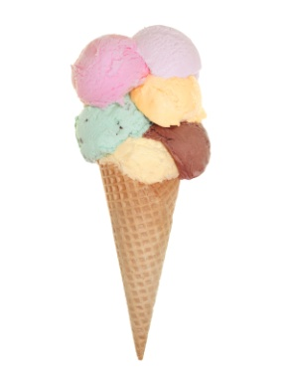
Scoop-on-Ice-Cream Recording Sheet

The Three Favorite Flavors of Ice Cream*

Favorite Flavor Percent of Those Polled
Vanilla 55%
Chocolate 29%
Strawberry 16%

Scrumptious Scoops is a very popular ice cream parlor in a small town in Virginia. To celebrate the Fourth of July, the store decided to serve free single scoops of its three most popular flavors to the audience at the Independence Day outdoor band concert.

Mr. Scrumptious decided that he could determine how much ice cream he would need by using the data provided by the International Ice Cream Association. The town estimated that approximately 650 people would attend the band concert.
- Assuming everyone will want a free scoop of ice cream, how many people would you expect to prefer chocolate?
- How many half-gallons of chocolate ice cream should Mr. Scrumptious plan to have on hand to give to those people?
- If the representatives from Scrumptious Scoops serve everyone at the band concert a scoop of ice cream, how many half-gallons of ice cream will they serve? How many pounds will that be?
Important Measurement Equivalents
A gallon of ice cream weighs about 5 pounds and contains 4 quarts.
One scoop of ice cream is $\frac{1}{2}$ cup or about 68 grams.
One gallon contains 16 cups, so one half-gallon contains 8 cups.

*data taken from https://www.iaicdv.org/

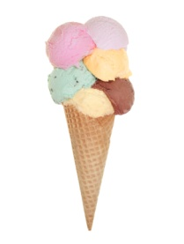
Ice Cream Recipe

Make ice cream in plastic zip-lock bags as follows:

- Combine 3 tablespoons of sugar, a few drops of vanilla extract, and 1 cup of milk in a 1-quart zip-lock bag, and seal the bag tightly. You may add cookie pieces or well-drained fruit to your ice cream mixture if you wish.
- Put about 2 cups of ice and $\frac{1}{2}$ cup of rock salt in a 1-gallon zip-lock bag. Use small ice cubes, or break the ice into small pieces.
- Put the smaller bag into the larger bag, and seal it tightly. Then shake the large bag until the ice cream mixture freezes. This step takes some time.

Why do you think this method works for making ice cream?

Using the recipe above, how many students could make ice cream using 8 cups of sugar and 4 gallons of milk? To solve the problem you need to know: 1 cup = 16 tbsp. and 1 gallon = 16 cups. Show your calculations in the box below:

Would there be any ingredients left over? If so, how much? Show your thinking below:

