AR Remediation Plan – Practical Applications-Rational Number and Proportional Reasoning

Practical Problems and Simple Interest

STRAND: Computation and Estimation

STRAND CONCEPT: Practical Applications-Rational Number and Proportional Reasoning

SOL 8.4

Remediation Plan Summary
Students practice solving practical problems, including simple interest, involving rational numbers.

Common Misconceptions
- Students may mix up the whole and the part when trying to write the proportion for the practical problem.
- Students will incorrectly set up the proportions by always putting the variable as the numerator in the second ratio or over 100.
- Students may forget to convert a percent to a decimal or fraction before solving the equation.

Materials
- Warm Up with Percents handout
- Walking Through Practical Problems recording sheet
- Practical Problems handout
- Solving Simple Interest handout

Introductory Activity
Copy and cut out the Warm Up with Percents cards. Give each student one card. The object of the warm up is for students to find their match. Fractions are given as images and numbers so students will be in groups of 3.

Plan for Instruction
- Distribute copies of the “Walking Through Practical Problems” recording sheet to students. Begin a discussion with students about what they should do when they encounter a practical problem involving rational numbers. Below are strategies that will be used to solve practical problems.
- Read the problem twice.
- Highlight the important pieces of information.
- Decide on a strategy.
- Decide whether you need to use an operation(s), and if so, why? (Allow students to justify their reasoning and encourage class discussion about student reasoning.)
- Solve the problem.
- Go back and check the answer to the problem.
- Have the students apply steps 1 and 2 individually to the problem on the worksheet. Discuss as a whole group.
- Have the students decide on a strategy in step 3. Students may have different strategies. Discuss the strategies they chose and how they are similar.
- Allow students to solve the problem using the strategy they chose. Display and discuss the solutions as a group.
- Discuss how important it is to check your answer. Ask students to complete this last step and discuss as a group.
- Based upon the discussions with students, decide whether you need repeat this process for problem 2, or whether the students are ready to work on their own. You may want to recreate a sheet with the steps listed for students to use as a checklist.
- Pass out the “Solving Simple Interest Problems work sheet to students. Walk through the steps for simple interest problems with the class. Be sure to include in the discussion the need to change months to years or years to months in the interest formula when necessary. Allow students to work on the two problems with a partner answering any questions they may have. Once the students are done, go over the answers as a group.

Pulling It All Together
Exit Ticket: Ask students to write a practical problem on their own and solve it. Have them exchange problems with a partner and solve.

Note: The following pages are intended for classroom use for students as a visual aid to learning.

Virginia Department of Education 2018

Name:

Warm Up with Percents
40% |  | $$\frac{2}{5}$$
80% | 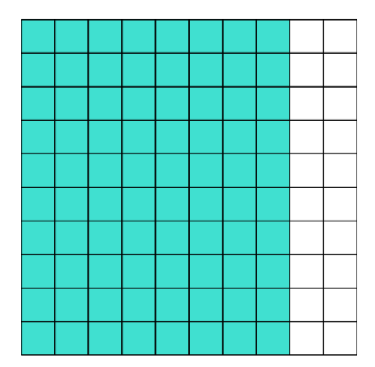 | $$\frac{4}{5}$$
30% |  | $$\frac{3}{10}$$
75% | 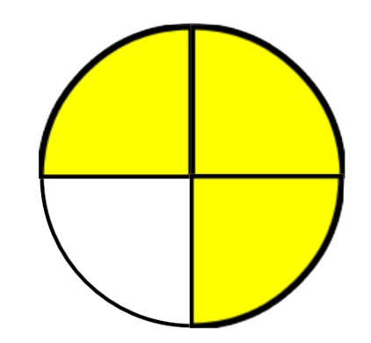 | $$\frac{3}{4}$$
94% |  | $$\frac{47}{50}$$
$$33 \frac{1}{3}\%$$ | 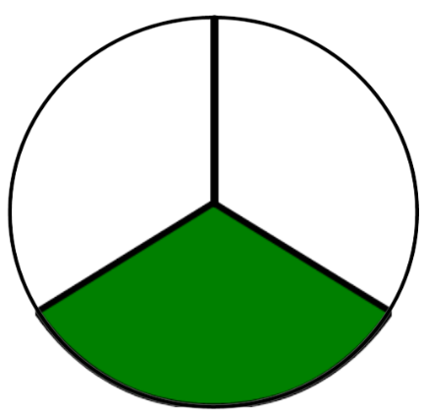 | $$\frac{1}{3}$$
10% |  | $$\frac{1}{10}$$
44% | 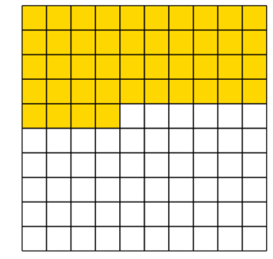 | $$\frac{11}{25}$$

Walking Through Solving Problems
Solve the following problem using the steps below. Show your work.
On a map of Virginia, Tammy sees that the distance between Richmond and Virginia Beach is 3 inches. The scale of the map is $\frac{1}{2}$ in. = 20 mi. What is the actual distance in miles between Richmond and Virginia Beach?

Step 1: Read the problem twice.
Step 2: Highlight the important pieces of information.

Step 3: Decide on a strategy.
Strategy: __________________________________________________________________

Step 4: Decide whether you need to use an operation(s), and if so, which one(s).
Operation(s): _______________________________________________________________

Step 5: Solve the problem.

Step 6: Go back and check the answer to the problem.

Name:

Practical Problems
Solve each of the following problems. Show your work.
1. On a map of Virginia, Tammy sees that the distance between Richmond and Virginia Beach is 3 inches. The scale of the map is $\frac{1}{2}$ in. = 20 mi. What is the actual distance in miles between Richmond and Virginia Beach?

2. The Gap is having a sale. They advertise $\frac{1}{5}$ off everything in the store. What percent is equal to $\frac{1}{5}$?

3. Jamie is $\frac{1}{4}$ as old as his father. If his father is 36, how old is Jamie?

4. Miles filled $\frac{1}{3}$ of his gas tank. His gas tank holds 12 gallons. How many gallons of gas did he put in his tank?

5. Macy’s is having a sale in which everything is $\frac{2}{5}$ off. At the same time, The Gap is having a sale in which everything is 30% off. Which store is giving the greater percent off?

6. Michelle bought 3 yards of ribbon to make bows. Each bow requires $\frac{2}{3}$ yard of ribbon. How many bows can Michelle make?

Solving Simple Interest Problems

When money is borrowed or invested, interest is paid or earned on the money. Simple interest is computed using this formula:
Interest = Principal × Rate × Time (I = p ∙ r ∙ t)
The principal is the amount of money borrowed or invested. The rate is the percent of interest per year. The time is the number of years the money is borrowed or invested.
Example 1
Julian invested $2,000 at 4% simple interest. How much is his investment worth after one and a half years?
1. List the values, and write percents and fractions as decimals.
p = 2,000
r = 4% = .04
t = 1$\frac{1}{2}$ = 1.5
2. Substitute the values into the formula for simple interest (I = p ∙ r ∙ t) and solve.
I = 2,000 × .04 × 1.5
I = 120
3. Add the simple interest to the principal.
2,000 + 120 = 2,120
Julian’s investment is worth $2,120 after one and a half years.
Example 2
Ashley invested $200 at 7% for 3 years. How much simple interest did her money earn?
1. List the values, and write percents and fractions as decimals.
p = 200
r = 7% = .07
t = 3
2. Substitute the values into the formula for simple interest (I = p ∙ r ∙ t) and solve.
I= 200 × .07 × 3
I = 42
Her money earned $42 in simple interest.

Practice
1. Martin invested the $800 he made at a summer job at 6% for one and a half years. How much simple interest did he earn on his investment?

2. Beth borrowed $350 at 10% simple interest for two and three-fourths years. How much interest did she have to pay?

