### *AR Remediation Plan – Rational Numbers – Estimation and Operations*

### Operations with Integers - Multiplication

### STRAND: Computation and Estimation

### STRAND CONCEPT: Rational Number – Estimation and Operations

### SOL 6.6a

#### Remediation Plan Summary

Students multiply integers, using manipulatives.

#### Common Misconceptions

* Students may ignore the signs and just multiply the integers.
* Student may think that multiplying two negative numbers results in a negative answer.
* Students may think that if the signs of the factors are different and the larger factor is positive, the answer is positive.
* Students may think that if the signs of the factors are different and the larger factor is negative, the answer is negative.

#### Materials

* It’s All in the Family warm up
* 2-color counters or Algebra tiles
* Recording Sheet for Models
* Multiplying Integers recording sheet
* Multiplying Integers-Part 2 recording sheet
* Compare and Contrast Reflection sheet

#### Introductory Activity

Distribute “It’s All in the Family” warm up sheet. Allow students to work on the problems on their own. Once students are done, discuss the answers and any patterns they noticed. Explain to students that these “fact families” are related and how the numbers are related. Ask students to create their own “Fact Family” problem set for a partner to solve.

#### Plan for Instruction

1. 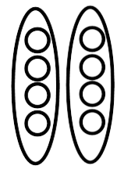Present the following problem to the students: . Ask a student to read this problem. (Most will say “2 times 4”) Explain to students that this mathematical expression represents “two groups of four”. Draw or display this model and tell students:   
   *One way to model this is*.  
   *The model shows how many groups?   
   How many are in each group?   
   So, the total number is?*

*_____ x _____ = _____*  
*groups # in group total*

1. If you have not used any of the previous integer lessons, you will need to introduce and display 2-color counters or Algebra tiles to the students. *What do you notice about the counters? What do you think the different colors represent?* Explain that the yellow side of the counter represents  and the red side of the counter represent. Display one yellow counter and one red counter. *What do we call these two numbers?* (additive inverses) *What is the sum of these two counters?*
2. Display the following problems one at a time and ask students to model along with you.   
          
   Answer question and ensure students understand they are making the number in each group and then repeating for the appropriate number of groups.
3. Distribute “Multiplying Integers” recording sheet. Discuss answers once students have completed it. Address any misconceptions students may have.
4.  *How did we read* *?* (Two groups of 4) *How do you read* *?* Allow students to respond. *This says the opposite of 2 groups of 4. You cannot have a negative number of groups, so you need to take the opposite.* Model this for the students by starting with the 2 groups of 4.   
     
     
     
     
     
     
   *How you would represent taking the opposite of this model?* If a student doesn’t suggest it, tell them they need to “flip” the counters to the other side.

Explain that the solution to is .   
*What do you think would happen if we solved the expression?* Model and solve this problem with the students. *How is this like the first problem? How is it different?*

1. Display the following problems one at a time and ask students to model along with you.   
          
   Answer question and ensure students understand they are making the number in each group and then repeating for the appropriate number of groups. The last step is to take the opposite or flip over the counters.
2. Distribute “Multiplying Integers-Part 2” recording sheet. Discuss answers once students have completed it. Address any misconceptions students may have.

#### Pulling It All Together (Reflection)

Exit Ticket: Complete the Compare and Contrast Reflection sheet.

**Note: The following pages are intended for classroom use for students as a visual aid to learning.**

Virginia Department of Education 2018

### Name: _________________________

**It’s All in the Family**

Complete the missing blanks in the in each box.

   

   

   

   

What do you notice about these problems?

### Name: _________________________

**KEY**

= 1 = -1

**Recording Sheet for Models**

|  |  |
| --- | --- |
| Number Sentence | Model |
| ____ ____ = ______  _____ groups of ______ |  |
| ____ ____ = ______  _____ groups of ______ |  |
| ____ ____ = ______  _____ groups of ______ |  |
| ____ ____ = ______  _____ groups of ______ |  |

**KEY**

= 1 = -1

|  |  |
| --- | --- |
| Number Sentence | Model |
| ____ _____ = ______  The opposite of _____ groups of ______. | 1: ___ groups of ___ 2: Opposite |
| ____ _____ = ______  The opposite of _____ groups of ______. | 1: ___ groups of ___ 2: Opposite |
| ____ _____ = ______  The opposite of _____ groups of ______. | 1: ___ groups of ___ 2: Opposite |
| ____ _____ = ______  The opposite of _____ groups of ______. | 1: ___ groups of ___ 2: Opposite |

### Name: _________________________

**KEY**

= 1 = -1

**Multiplying Integers**

Write an equation for each model.

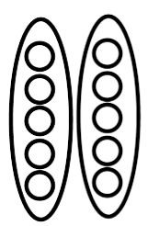

1. 2.





1. 4.





### Name: _________________________

**KEY**

= 1 = -1

**Multiplying Integers-Part 2**

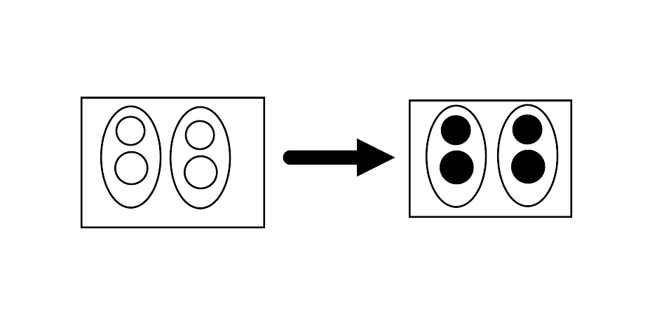Example:

1. This has 2 groups
2. This has 2 in each group
3. This will be **-2 x 2**
4. The total after taking the opposite is **-4**

The multiplication sentence is -2 x 2 = -4.

Write an equation for each model.

1.  2.
2.  4.



### Name: _________________________

**Compare and Contrast!**

Compare and contrast the two Addition Sentences. How are they alike? How are they different?

How are they alike?

How are they different??

$$-4×(2)$$

$$4×(-2)$$