### *AR Remediation Plan – Rational Numbers – Estimation and Operations*

### Operations with Integers - Division

### STRAND: Computation and Estimation

### STRAND CONCEPT: Rational Number – Estimation and Operations

### SOL 6.6a

#### Remediation Plan Summary

Students divide integers, using manipulatives.

#### Common Misconceptions

* Students may ignore the signs and just divide the integers.
* Student may think that dividing two negative numbers results in a negative answer.
* Students may think that if the signs different and the larger number is positive, the answer is positive.
* Students may think that if the signs are different and the larger number is negative, the answer is negative.

#### Materials

* Three Ways warm up activity
* 2-color counters or Algebra tiles
* Recording Sheet for Models
* Dividing Integers recording sheet
* Dividing Integers-Part 2 recording sheet
* Compare and Contrast Reflection sheet

#### Introductory Activity

Distribute “Three Ways” warm up activity. Explain to students that they are going to model the problems 3 different ways. The first way will be a picture of the problem. The second method will use counters to create a mathematical model. The last column asks the student to write the equation. Allow students to try this on their own but if students are struggling, you can help students with the first problem or you (the teacher) can write a similar problem and model the process for the students.

#### Plan for Instruction

1. Present the following problem to the students: . Ask a student to read this problem. (Most will say “8 divided by2”) Explain to students that this mathematical expression represents “a quantity of 8 divided into 2 groups”. Draw or display this model and tell students:   
   *One way to model this is*.   
   *Step 1: Start with your total.  
   Step 2: Divide your total into equal groups.  
   Step 3: Determine how many are in each group.   
   So, the answer to*  *is? _________*

*_____ ÷ _____ = _____*  
*total # of groups # in group*

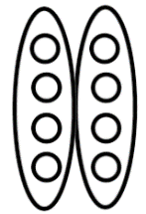

1. If you have not used any of the previous integer lessons, you will need to introduce and display 2-color counters or Algebra tiles to the students. *What do you notice about the counters? What do you think the different colors represent?* Explain that the yellow side of the counter represents  and the red side of the counter represent. Display one yellow counter and one red counter. *What do we call these two numbers?* (additive inverses) *What is the sum of these two counters?*
2. Display the following problems one at a time and ask students to model along with you.   
          
   Answer questions and ensure students understand they are making the number in each group and then repeating for the appropriate number of groups.
3. Distribute “Dividing Integers” recording sheet. Discuss answers once students have completed it. Address any misconceptions students may have.
4. *How did we read* *?* (a quantity of 8 divided into 2 groups) *How do you read* *?* Allow students to respond. *Just like in multiplication of integers, we cannot have negative groups. So after you split the model into groups, you will need to take the opposite.* Model this for the students by starting with the quantity of 8 and split it into 2 groups.   
     
     
     
     
     
   *How you would represent taking the opposite of this model?* If a student doesn’t suggest it, tell them they need to “flip” the counters to the other side.



Explain that the solution to is .   
*How is this like the first problem? How is it different?*

1. Display the following problems one at a time and ask students to model along with you.   
          
     
   Answer questions and display the steps if necessary for students to follow.

*Step 1: Start with the total.  
Step 2: Divide your total into the number of groups.  
Step3: Take the opposite.  
Step 4: Determine how many are in each group.*

1. Distribute “Dividing Integers-Part 2” recording sheet. Discuss answers once students have completed it. Address any misconceptions students may have.

#### Pulling It All Together (Reflection)

Exit Ticket: Complete the Compare and Contrast Reflection sheet.

**Note: The following pages are intended for classroom use for students as a visual aid to learning.**

Virginia Department of Education 2018

### Name: _________________________

**Three Ways**

**For each story problem, draw a pictorial representation, a model and an equation.**

|  |  |  |
| --- | --- | --- |
| Rhonda baked cookies last night and put them into three bags. In each bag there are four cookies. How many cookies did Rhonda bake? | | |
| **Pictorial Representation** | **Model with Counters** | **Equation** |
|  |  |  |

|  |  |  |
| --- | --- | --- |
| On one winter evening, the temperature dropped three degrees an hour for 4 hours. What integer represents this change in temperature? | | |
| **Pictorial Representation** | **Model with Counters** | **Equation** |
|  |  |  |

### Name: _________________________

**KEY**

= 1 = -1

**Recording Sheet for Models**

|  |  |  |
| --- | --- | --- |
| Number Sentence | Model | Quotient |
|  |  |  |
|  |  |  |
|  |  |  |
|  |  |  |

**KEY**

= 1 = -1

|  |  |  |
| --- | --- | --- |
| Number Sentence | Model | Quotient |
|  |  |  |
|  |  |  |
|  |  |  |
|  |  |  |

### Name: _________________________

**KEY**

= 1 = -1

**Dividing Integers**

Write an equation for each model.

1. 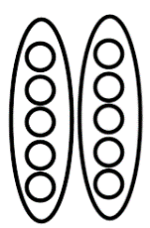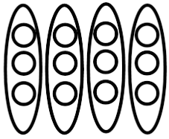2.



*_____ ÷ _____ = _____ _____ ÷ _____ = _____*  
 *total # of groups # in group*

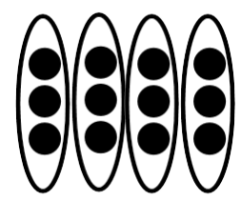

1. 4.

*_____ ÷ _____ = _____ _____ ÷ _____ = _____*

### Name: _________________________

**KEY**

= 1 = -1

**Dividing Integers-Part 2**

Example:

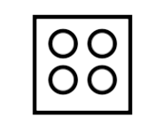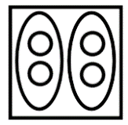

1. The total is 4.
2. Split the total into 2 equal groups.
3. Find the opposite of the 2 groups.
4. The number in each group is -2.

The division sentence is 4 ÷(- 2) = -2.

Write an equation for each model.

1. 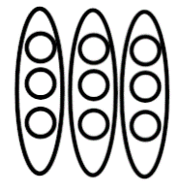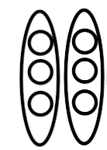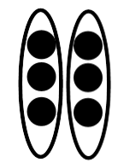 2.   
     
     
     
     
     
     
   *_____ ÷ _____ = _____ _____ ÷ _____ = _____*
2. 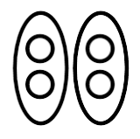 4.



*_____ ÷ _____ = _____ _____ ÷ _____ = _____*

### Name: _________________________

Compare and Contrast!

Compare and contrast the two Addition Sentences. How are they alike? How are they different?

How are they alike?

How are they different??

$$4×(-2)$$

$$-8÷4$$